COMMUNITY SERVICE REQUEST MANAGEMENT SYSTEM
FOR BARANGAY SAN RAFAEL
UNIVERSITY OF LA SALETTE, INC.
COLLEGE OF INFORMATION TECHNOLOGY
PCCBSIT 006 – APPLICATION DEVELOPMENT AND EMERGING TECHNOLOGIES
ASSESSMENT A2 – APPLICATION PLANNING AND DESIGN
SNC – SERVICE LEARNING COMPONENT
[SUBJECT CODE] – [SUBJECT TITLE]
Prepared by:
GROUP 5
Dionisio, Joseph R.
Mariano, John Idrian
Martin, Jhade Lorenz C.
Namoc, Charles Klyde T.

BSIT 3A
Date of Submission: September 2026
Submitted to:
Sir Michael Baltazar (PCCBSIT 006)
[Instructor Name] ([SUBJECT CODE])

TABLE OF CONTENTS
1. Client Profile 3
2. Statement of the Problem 4
3. Stakeholders 6
4. Proposed Application 6
5. Application Objectives 8
6. Application Scope 8
7. Functional Requirements 11
8. Non-Functional Requirements 12
9. Application Architecture 13
10. Application Components 14
11. Data Flow 16
12. Navigation Plan 18
13. Interface / Wireframes 20
14. Technology Selection 35
15. Usability Considerations 35
16. Requirements-to-Design Traceability 37
17. Consultation and Revision – Meeting Agenda 51
18. Final Proposed Design 52
19. Conclusion 54

1. Client Profile

1.1 Organization Information
Item | Information
Organization Name | Barangay San Rafael
Organization Type | Barangay Office / local government office context
Main Services | Certificates, clearances, community assistance, complaint handling, referral services, and other resident requests requiring review or approval.
Target Users | Residents (as registered account holders), front-desk employees, barangay secretary, barangay captain, and council members.
Available Resources | Computers, printer, basic spreadsheet and word-processing software, and internet access that is available but not always dependable.
Key Constraints | Limited funds, varying levels of computer familiarity, privacy concerns, and paper procedures that may still be required.

1.2 Current Process
Residents approach the receiving table, explain what they need, and present identification or supporting documents. Staff may provide forms for selected requests, while other concerns are recorded directly in logbooks. Completed forms are placed in folders by service type. The barangay secretary later reviews requests and determines which items need barangay captain approval, which can be processed by authorized staff, and which require additional documents.
The office maintains separate logbooks for certificates and clearances, complaints, and community assistance or referrals. Some information is also encoded into spreadsheets for periodic reporting. As a result, the same resident may appear in several records with inconsistent spellings, addresses, or contact information. Complaint follow-ups and other actions may be recorded in separate notes or personal notebooks.

1.3 Client Context and Assumptions
Barangay San Rafael is used as the client context for this student-developed system. The group will implement a simple working web application based on the supplied scenario. The design prioritizes a manageable Laravel implementation, existing office resources, privacy of resident information, and continued paper procedures where required.
The system uses three application roles: Administrator, Staff, and User/Resident. Residents register their own accounts and submit service requests through the application. Before a resident account is activated, Staff or the Administrator verify the resident's residency by checking an uploaded valid ID image. Staff and the Administrator process requests and maintain records, while a Resident can see and manage only his or her own requests and tickets. This keeps the system practical while addressing centralized records, request status tracking, and follow-up monitoring.
Fulfillment remains offline. For services that carry a fee, the resident presents the reference number at the barangay hall, pays cash upon receiving the document, and the Administrator marks the request as Completed. The system does not process online payments and does not send SMS or email notifications; request status is shown inside the resident dashboard only.

2. Statement of the Problem

2.1 Background of the Problem
Barangay San Rafael relies on a combination of paper forms, folders, multiple logbooks, spreadsheets, and individual notes to manage certificates, clearances, complaints, community assistance, referrals, and other resident requests. Because the same information can be recorded in more than one place, resident records may contain inconsistent spellings, addresses, or contact information.
The scenario also shows that pending requests and follow-up actions can be difficult to track. The secretary may keep a separate handwritten list for requests that need signatures or follow-up, while complaint actions may be stored in another notebook. When the employee who handled a case is absent, another staff member may have difficulty determining the latest status. These conditions can also make periodic reporting more labor-intensive.

2.2 Problem Statement
The primary problem is the absence of a centralized and consistent method for recording, monitoring, retrieving, and reporting barangay service requests and follow-up information that is currently distributed across multiple paper and digital records.

2.3 Effects of the Problem
- Staff may spend additional time searching folders, logbooks, spreadsheets, or separate notes.
- Residents may receive less predictable information about when their requests or documents will be ready.
- Complaint follow-up histories may be difficult to reconstruct when information is recorded in separate places.
- Reports may require manual counting or consolidation from multiple records.
- Inconsistent resident information may make record matching and retrieval more difficult.

2.4 Why an Application Could Help
A centralized application can provide authorized personnel with one organized location for recording requests, updating statuses, monitoring pending actions, retrieving records, and generating basic summaries. It can also let residents check the status of their own requests, and see which documents a service requires, without relying on repeated visits to the office. This directly addresses the scenario's dependence on separate logbooks, spreadsheets, folders, and personal notes.

3. Stakeholders
Stakeholder | Role | Needs / Expectations
Residents | Register an account, submit requests with the required documents, track status, pay any fee in cash upon receipt, and open support tickets. | Fewer repeat visits, a clear list of required documents, an understandable request status, and a way to ask questions without waiting in line.
Front-Desk Employees | Receive walk-in residents, record initial information, and create staff-assisted requests. | Simple data entry, reduced duplicate work, easy record retrieval, and a way to help residents who cannot use the portal.
Barangay Secretary (Ms. Flores) | Reviews requests, monitors pending items, prepares reports, and tracks follow-ups. | Clear visibility of pending actions, approvals, follow-ups, and report-ready information.
Barangay Captain | Reviews and signs selected documents or cases. Official signatures remain on paper. | Access to items requiring review or approval with relevant information.
Council Members | May request information about complaints, programs, or assistance. | Organized information and reports for authorized use.
Administrator | Maintains service types, fees, and document checklists; manages user accounts; sets requests to Completed after cash fulfillment. | Control over service configuration, accurate completion records, and secure role-based access.

4. Proposed Application
Item | Proposed Application
Application Name | Community Service Request Management System for Barangay San Rafael
Application Type | Proposed web-based application
Main Purpose | Centralize the recording, monitoring, retrieval, and status tracking of selected barangay service requests and related follow-up activities, and give verified residents a self-service portal to submit requests, upload required documents, track status, and raise issue tickets.
Target Users | Administrator, Staff, and User/Resident (verified resident account holders).
Problem Addressed | Fragmented records, inconsistent information, difficulty tracking pending work, difficulty retrieving follow-up information, and residents' repeated visits to ask about request status.

4.1 Application Description
The Community Service Request Management System is a simple web application for Barangay San Rafael with three roles. Residents register an account, which Staff or the Administrator activate after verifying a valid ID. A verified resident selects a service type, sees its fee and required-document checklist, uploads the documents, and receives a unique reference number. The resident dashboard shows a status tracker and any amount due.
Staff review each request and move it through one status workflow: Submitted, Under Review, Approved, Cash Payment, and Completed. Staff may set statuses up to Cash Payment, and only the Administrator sets Completed. Services with a ₱0.00 fee skip Cash Payment. Staff can also create requests on behalf of residents, add follow-up notes, search records, and answer residents' issue tickets. The Administrator maintains service types, fees, and document checklists. Certificate/clearance, complaint, and assistance/referral concerns are handled as service categories within one request workflow.

4.2 Implementation Boundary
This manuscript documents the planned and designed student-developed system that will be implemented using Laravel and MySQL. It is based on the supplied Barangay San Rafael scenario and does not claim that Barangay San Rafael has already adopted the system or that the application is an official government information system.

5. Application Objectives
- To centralize resident and service-request records so authorized personnel can retrieve information from one system.
- To give residents a verified self-service account for submitting certificate/clearance, complaint, and assistance/referral requests, with a document checklist that adjusts to the selected service type.
- To apply one status workflow (Submitted, Under Review, Approved, Cash Payment, Completed) with role-limited updates, a request log, and offline cash-upon-delivery fulfillment.
- To let residents track their requests, reference numbers, and amounts due from a personal dashboard without repeated visits to the office.
- To provide an asynchronous issue ticketing system through which residents can raise concerns and Staff can answer them without live chat.
- To provide a dashboard and basic reports that help staff monitor pending and completed requests without manually consolidating several records.
- To protect resident information through authentication, role-based access, private storage of uploaded files, and a consent notice aligned with the Data Privacy Act of 2012 (RA 10173).

6. Application Scope

6.1 In Scope
- Login and role-based access for the Administrator, Staff, and User/Resident roles.
- Resident self-registration with valid ID upload and a data-privacy consent notice, followed by verification by Staff or the Administrator.
- Service-request submission by residents, and staff-assisted submission on behalf of residents.
- A document checklist that changes with the selected service type, with uploads in JPG, PNG, or PDF format of up to 5 MB each.
- Resident/requester information management needed for request processing.
- One status workflow with a request log and follow-up notes, including complaint follow-up through the same Service Request record.
- A resident dashboard showing the reference number, status tracker, and amount due.
- Offline cash-upon-delivery fulfillment, with completion recorded by the Administrator.
- An asynchronous issue ticketing system for resident concerns, with Open, Answered, and Closed statuses.
- Administrator maintenance of service types, fees, and document checklists.
- Search and retrieval of request records, a staff dashboard, and basic reports for pending, completed, and selected transaction categories.

6.2 Out of Scope
- Replacement of all legally or administratively required paper records.
- Online payments and payment gateways (fees are paid in cash at the barangay hall).
- Live chat between residents and staff.
- SMS or email notification infrastructure.
- Digital signatures.
- Full accounting, payroll, or other unrelated municipal systems.
- Purchase or management of specialized hardware.
- Guaranteed online operation during internet outages.
- Official barangay adoption, production deployment, or use of real resident records.

6.3 Scope Limitations
The Minimum Viable Product (MVP) uses a focused workflow. A resident registers and is verified, submits a service request with the required documents, and tracks it on a dashboard. Staff and the Administrator process the request through one status workflow, record follow-up actions, search previous records, and generate basic reports. Service categories are handled within the same transaction model to keep implementation manageable.
Issue tickets are asynchronous by design. Live chat would require staff to be available in real time to answer residents, which would overwhelm an understaffed barangay office that already serves walk-in residents at the receiving table. A ticket lets a resident write a concern at any time and lets Staff reply between front-desk tasks, while the full conversation stays attached to a ticket number (for example, TK-2026-0012) for later reference.
Online payments, digital signatures, SMS/email notification infrastructure, advanced analytics, and unrelated municipal subsystems are outside the MVP because they would increase development effort without directly solving the central record-management problem. Payment is made in cash at the barangay hall upon receiving the document, and residents check their status inside the dashboard.

7. Functional Requirements
Requirement ID | Functional Requirement
FR-01 | The system shall require login for the Administrator, Staff, and User/Resident roles and restrict actions and views based on role, so only permitted users can view or edit resident and request data.
FR-02 | The system shall allow a verified resident to submit a Service Request, and shall allow Staff or the Administrator to create one on behalf of a resident (staff-assisted), by selecting a service type (certificate/clearance, complaint, or community assistance/referral) within a single unified workflow. Each request shall receive a unique reference number (e.g., SR-2026-0006).
FR-03 | The system shall allow Staff and the Administrator to record and manage resident details needed to process a request, including the verification status of the resident.
FR-04 | The system shall apply one status workflow to every Service Request: Submitted, Under Review, Approved, Cash Payment, and Completed. Staff may set statuses up to Cash Payment; only the Administrator may set Completed. Services with a ₱0.00 fee skip Cash Payment (Approved to Completed). Every status change shall be saved in the request log.
FR-05 | The system shall allow Staff and the Administrator to add follow-up actions or notes to a Service Request, building a single chronological history for that record, including complaint follow-up, rather than a separate log.
FR-06 | The system shall allow Staff and the Administrator to search and filter Service Request and resident records (e.g., by reference number, resident, service type, status, date).
FR-07 | The system shall provide a staff dashboard giving an at-a-glance view of requests by status, pending resident verifications, and open tickets without manually consolidating records.
FR-08 | The system shall generate basic reports summarizing requests by status, service type, and date range, including the cash collected for completed requests.
FR-09 | The system shall allow a resident to register an account with personal details, a valid ID image, and acceptance of a data-privacy consent notice. The account shall remain inactive until Staff or the Administrator verify the resident's residency.
FR-10 | The system shall show a document checklist that changes with the selected service type, and shall accept uploads in JPG, PNG, or PDF format of up to 5 MB each. A request cannot be submitted until every required document is attached.
FR-11 | The system shall provide each resident with a dashboard showing only his or her own requests, with the reference number, a status tracker, and the amount due. Status shall be shown inside the dashboard only (no SMS or email notification).
FR-12 | The system shall support offline cash-upon-delivery fulfillment: the resident presents the reference number at the barangay hall and pays cash upon receiving the document, and the Administrator marks the request Completed. The system shall not process online payments.
FR-13 | The system shall provide an asynchronous issue ticketing system in which residents open tickets (optionally linked to a request) and Staff or the Administrator reply. Ticket statuses shall be Open, Answered, and Closed. Ticket numbers follow the format TK-2026-0012.
FR-14 | The system shall allow the Administrator to maintain service types, their fees (including ₱0.00), and the required-document checklist for each service type.

8. Non-Functional Requirements
Quality Attribute | Non-Functional Requirement
Usability | The interface shall use clear labels, simple forms, predictable navigation, and understandable status values for Residents, Staff, and the Administrator with different levels of computer familiarity.
Performance | Common record searches, dashboard pages, and document uploads should complete efficiently under normal office use.
Security | Resident and complaint-related information shall require authenticated access. Each role shall see only the data and functions permitted to it, residents shall see only their own records, and uploaded IDs and documents shall be kept in private storage that is not publicly accessible.
Reliability | The system shall validate required fields and uploaded files (JPG, PNG, or PDF, up to 5 MB) before saving, and shall preserve successfully stored request records and their logs.
Responsiveness | The interface shall remain readable and usable on the office computer screens and the smaller screens residents are likely to use.
Maintainability | The Laravel application shall separate routes, controllers, models, views, and migrations using a simple MVC structure.
Data Minimization | The system shall collect only the resident and request information necessary for the defined service-request workflow, shall present a consent notice at registration, and shall handle personal data in line with the Data Privacy Act of 2012 (RA 10173).

9. Application Architecture

9.1 Architecture Diagram
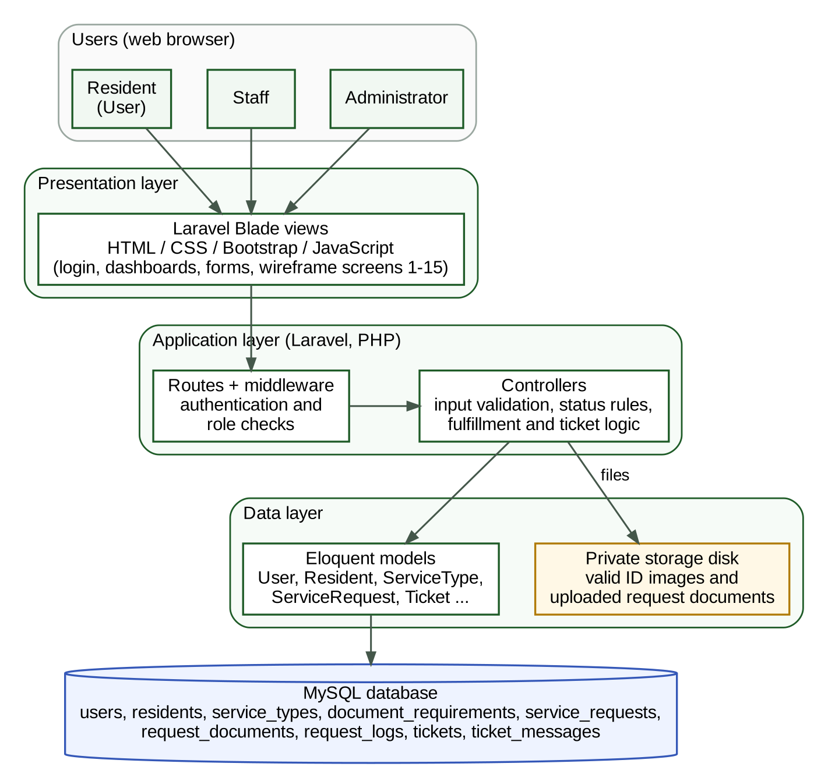
Figure 1. Application Architecture Diagram
Blade presents the interface, controllers process requests, Eloquent represents records, MySQL stores persistent data, and uploaded files stay on a private storage disk.

9.2 Architecture Explanation
Architecture Component | Role in the Proposed System
User Interface | Laravel Blade views with HTML/CSS/Bootstrap and JavaScript provide the login, registration, resident dashboard, submission form, ticket, staff, administrator, and report screens.
Application / Business Logic | Laravel routes, middleware, and controllers validate input, apply the status workflow and fee rules, generate reference numbers, and enforce roles.
Data / Model Layer | Eloquent models (e.g., Resident, Service Request, Ticket) represent database records as objects, letting Controllers query and save data without writing raw SQL.
Database | MySQL stores users, residents, service types, document requirements, service requests, request documents, request logs, tickets, and ticket messages as persistent rows.
Security / Access Control | Laravel's authentication and role middleware restrict which actions and views each role can reach; residents can open only their own records.
File Storage | Uploaded valid ID images and request documents (JPG, PNG, or PDF, up to 5 MB each) are saved on Laravel's private storage disk and served only through authenticated actions; the database stores the file paths.

The architecture follows a simple MVC structure because the group has beginner-level Laravel experience. This keeps views, request handling, database access, and migrations organized without introducing unnecessary framework complexity.

10. Application Components
Component / Module | Main Functions | Primary Users
Authentication and User Management | Login, logout, roles, activation of resident accounts, and basic user administration. | All roles
Resident Registration and Verification | Self-registration with valid ID upload and consent notice; verification of residency. | Resident / Staff / Administrator
Resident Management | Create, update, search, and reuse resident records. | Administrator / Staff
Service Type and Checklist Management | Maintain service types, fees (including ₱0.00), and required-document checklists. | Administrator
Service Request Management | Submit requests (resident or staff-assisted), upload documents, and view, search, and track requests. | Resident / Staff / Administrator
Status, Fulfillment and Follow-up Monitoring | Update status, record cash-upon-delivery fulfillment, complete requests, and keep a chronological request log. | Staff / Administrator
Resident Dashboard | Show reference number, status tracker, and amount due. | Resident
Issue Ticketing | Open tickets, reply, and close tickets (Open, Answered, Closed). | Resident / Staff / Administrator
Dashboard and Reports | Status counts, pending verifications, open tickets, request summaries, and date/service type/status filtering. | Administrator / Staff
Database and File Storage | Users, residents, service types, requests, documents, logs, tickets, and uploaded files. | System

10.1 Core Database Tables
The database has nine core tables. Together with the functional requirements in Section 7, they are the blueprint for the Laravel migrations and models.
Table | Main Fields | Purpose
users | id, username, password (hashed), role (administrator / staff / resident), status (pending / active / rejected) | Login accounts and role-based access.
residents | id, user_id, full_name, address, purok, contact_number, valid_id_path, verification_status, verified_by | Reusable resident records and residency verification.
service_types | id, name, category, fee, is_active | Services offered and their fees (₱0.00 allowed).
document_requirements | id, service_type_id, document_name, is_required | Required-document checklist for each service type.
service_requests | id, reference_no, resident_id, service_type_id, purpose, status, fee_amount, received_at, created_by, completed_by | Core transaction, e.g., reference number SR-2026-0006.
request_documents | id, service_request_id, document_requirement_id, file_path, original_name, file_size | Files uploaded for a request.
request_logs | id, service_request_id, user_id, entry_type (status / note), old_status, new_status, note, created_at | Status history and follow-up notes.
tickets | id, ticket_no, resident_id, service_request_id (optional), subject, status (Open / Answered / Closed) | Issue tickets, e.g., TK-2026-0012.
ticket_messages | id, ticket_id, user_id, message, created_at | Messages exchanged inside a ticket.

11. Data Flow

11.1 Data Flow Diagram
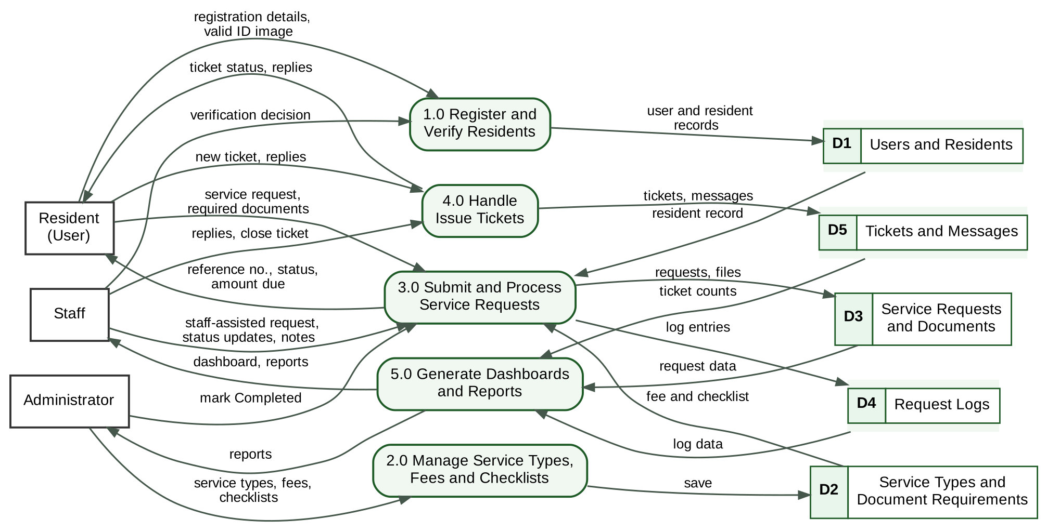
Figure 2. Data Flow Diagram
Residents, Staff, and the Administrator exchange data with five processes, which read and write five data stores.

11.2 Process and Data Store Descriptions
Process / Store | Description
1.0 Register and Verify Residents | Receives registration details and the valid ID image from the resident and the verification decision from Staff or the Administrator; saves accounts and resident records in D1.
2.0 Manage Service Types, Fees and Checklists | Receives service types, fees, and checklists from the Administrator and saves them in D2.
3.0 Submit and Process Service Requests | Receives requests and documents from residents or staff-assisted entries, reads the fee and checklist from D2 and the resident record from D1, applies the status workflow, and saves requests and files in D3 and log entries in D4.
4.0 Handle Issue Tickets | Receives new tickets and replies from residents and replies from Staff, and saves tickets and messages in D5.
5.0 Generate Dashboards and Reports | Reads D3, D4, and D5 to produce the staff dashboard and the reports for Staff and the Administrator.
D1 Users and Residents | users and residents tables.
D2 Service Types and Document Requirements | service_types and document_requirements tables.
D3 Service Requests and Documents | service_requests and request_documents tables, plus the private files.
D4 Request Logs | request_logs table.
D5 Tickets and Messages | tickets and ticket_messages tables.

11.3 Typical Transaction
A typical transaction begins when a resident registers an account and uploads a valid ID. Staff or the Administrator verify the resident, and the account becomes active. The resident then selects a service type, and Laravel loads the fee and the document checklist for that service type. The resident attaches the required files, and Laravel validates the input, assigns a unique reference number, sets the status to Submitted, and stores the request, the files, and the first log entry in MySQL.
When Staff update the status or add a follow-up note, the system records the change in the request log. Staff may set statuses up to Cash Payment; the resident dashboard shows the updated status and any amount due. For a service with a fee, the resident presents the reference number at the barangay hall and pays cash upon receiving the document, after which the Administrator marks the request Completed. Dashboard and report screens query the stored records to show pending work and summaries. This keeps the latest recorded information with the request instead of separating it into notebooks or other files.
A resident who needs help opens an issue ticket instead of using live chat. Staff answer when they are available, and the ticket status changes from Open to Answered, and later to Closed.

12. Navigation Plan

12.1 Resident Navigation Map
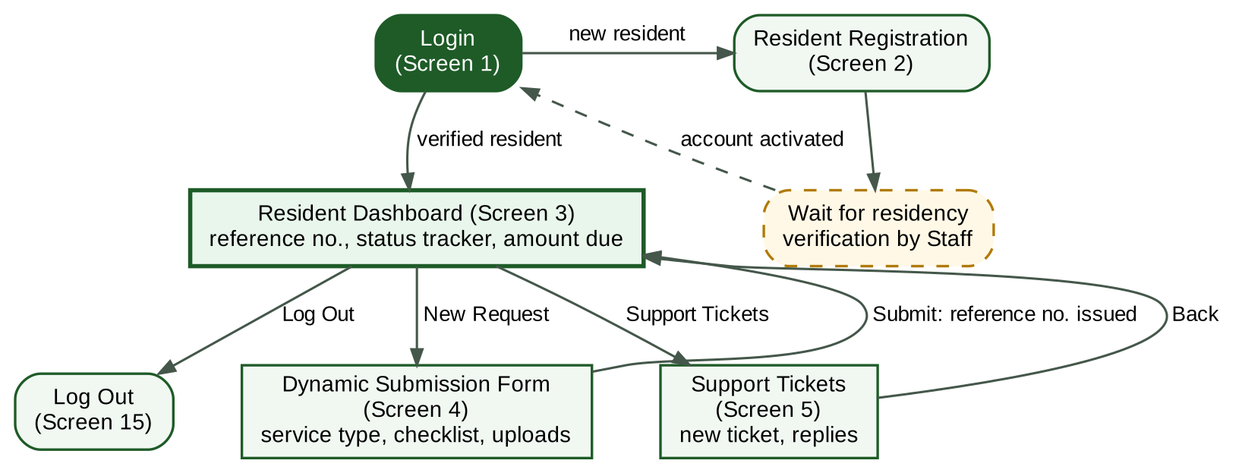
Figure 3. Resident Navigation Map
A new resident registers and waits for verification; a verified resident lands on the dashboard.
A new resident registers from the login screen and waits for Staff to verify residency. After login, a verified resident enters the Resident Dashboard, where the resident can start a request in the Dynamic Submission Form, follow a status tracker, open Support Tickets, and log out.

12.2 Staff and Administrator Navigation Map
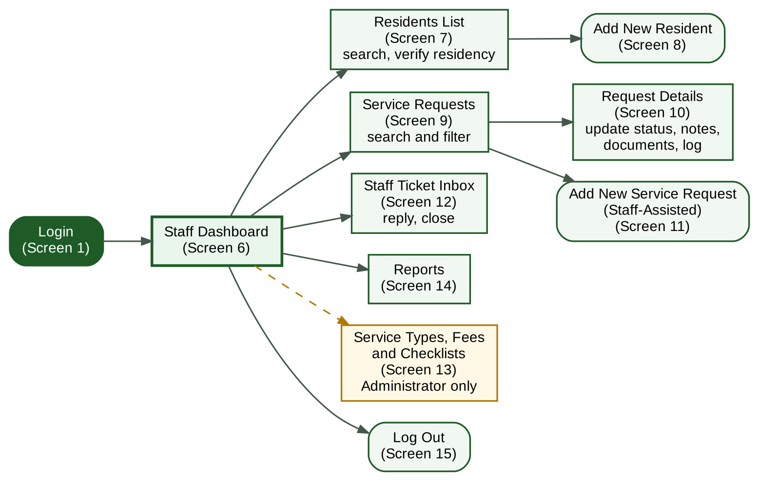
Figure 4. Staff and Administrator Navigation Map
The main menu keeps frequent staff tasks within a simple path; Service Types is visible only to the Administrator.
After login, Staff and the Administrator enter the dashboard. From the dashboard they can maintain Residents (including residency verification), search Service Requests, open Request Details to update status or add follow-up notes, answer tickets in the Ticket Inbox, and access Reports. Administrative functions such as Service Types, Fees and Checklists and user management are visible only to the Administrator role. Common functions stay reachable from the dashboard with minimal navigation.

13. Interface / Wireframes
The fifteen screens below follow the roles. Screens 1 and 2 are shared entry points, Screens 3 to 5 are for Residents, Screens 6 to 12 and 14 are for Staff and the Administrator, Screen 13 is for the Administrator only, and Screen 15 appears for every role. Names, reference numbers, and amounts in the screens are sample data only.
Screen 1 – Login
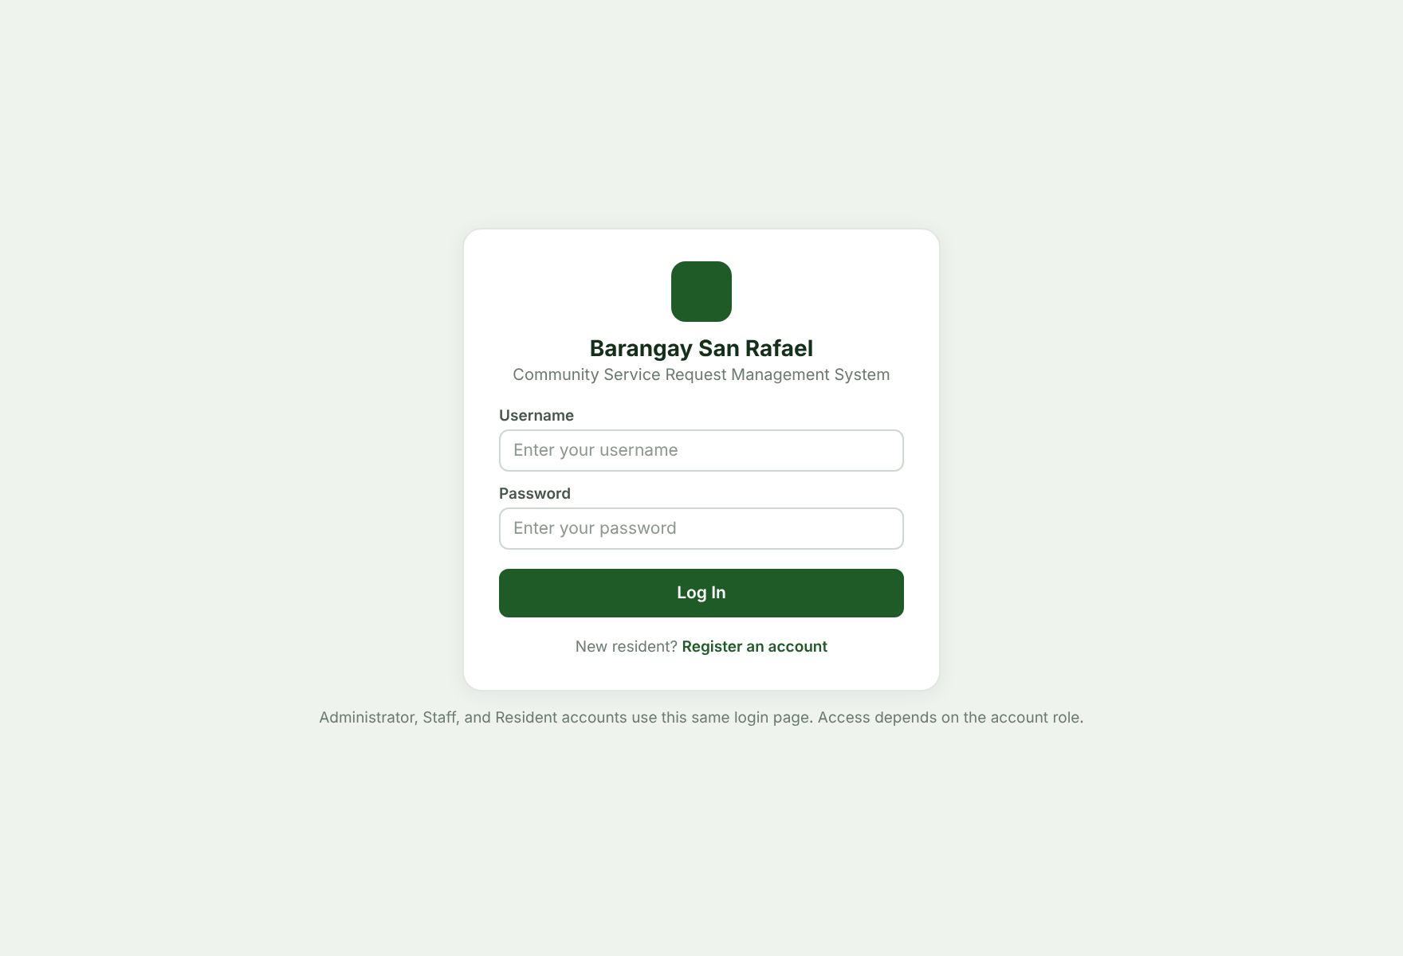
Figure 5. Login Wireframe
The login screen accepts the minimum credentials needed for authenticated access that includes Username input and Password input, and links new residents to registration. All three roles use this screen.
Screen 2 – Resident Registration
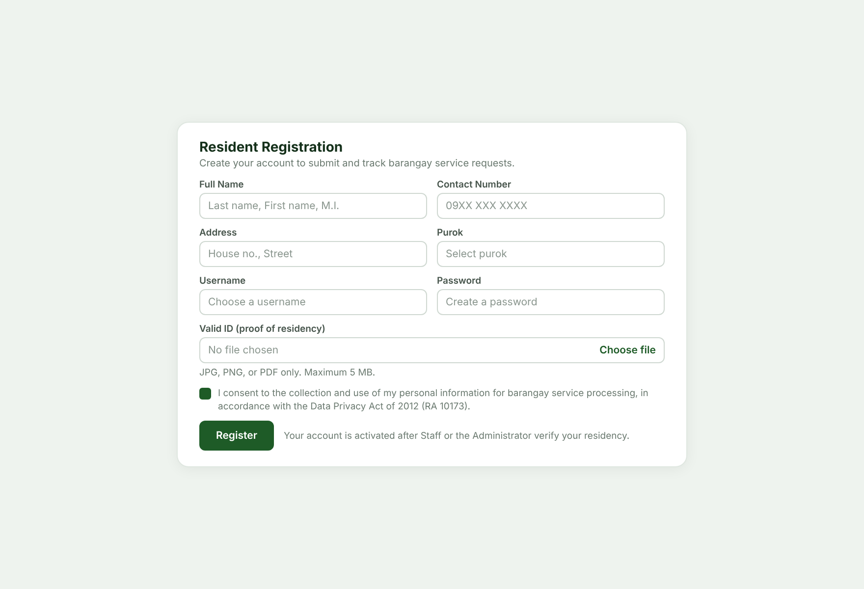
Figure 6. Resident Registration Wireframe
The registration screen collects the resident's name, address, purok, contact number, username, password, and valid ID image (JPG, PNG, or PDF up to 5 MB), and requires the data-privacy consent before the account is created for verification.
Screen 3 – Resident Dashboard
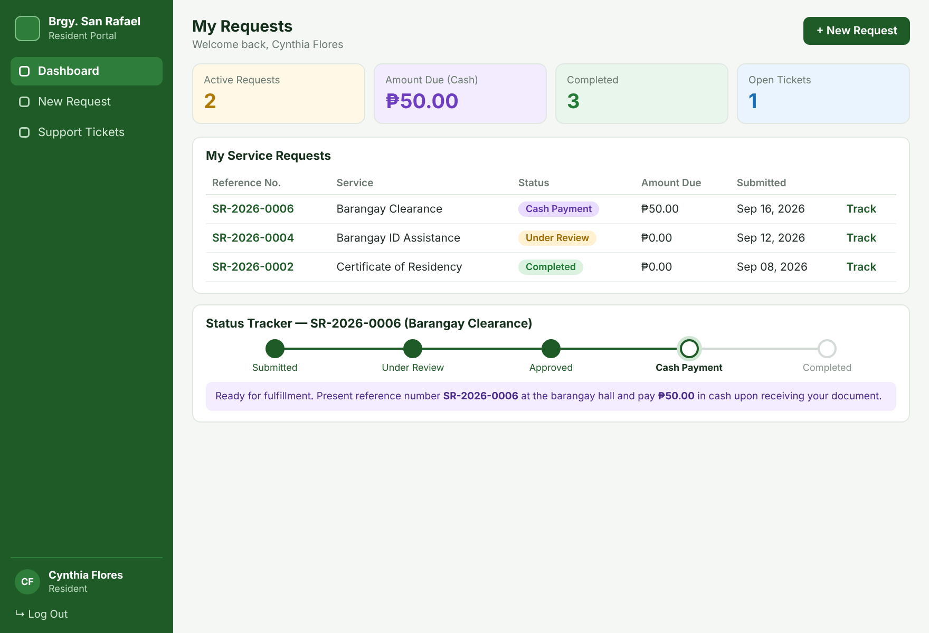
Figure 7. Resident Dashboard Wireframe
The resident dashboard lists only the resident's own requests with the reference number, status, and amount due, and shows a status tracker from Submitted to Completed with the cash-payment instruction.
Screen 4 – Dynamic Submission Form
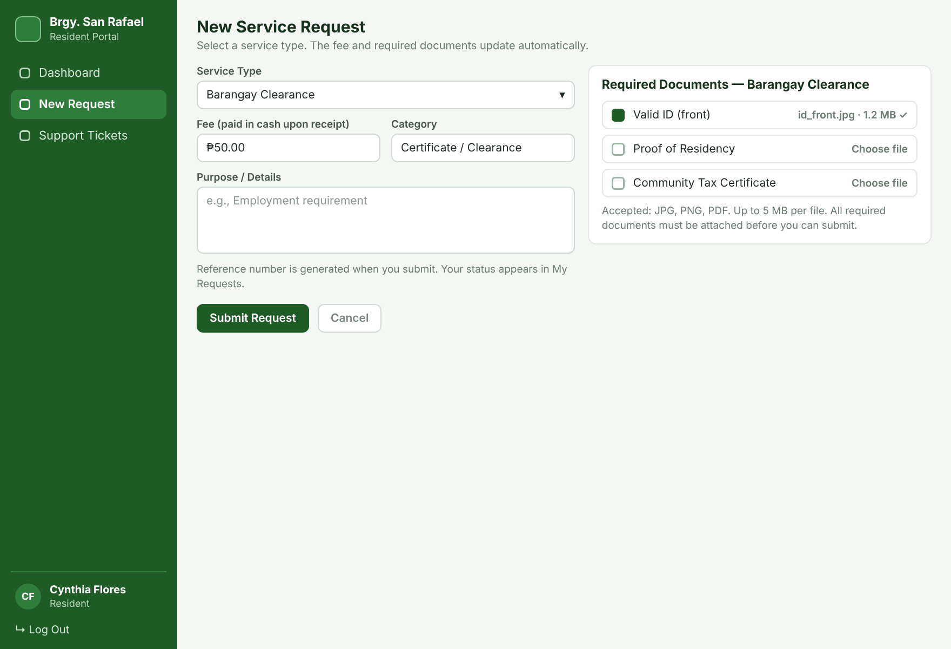
Figure 8. Dynamic Submission Form Wireframe
Selecting a service type shows its fee and a document checklist that changes with the service. Each required document is uploaded in JPG, PNG, or PDF format, and the request can be submitted only when the checklist is complete.
Screen 5 – Resident Support Tickets
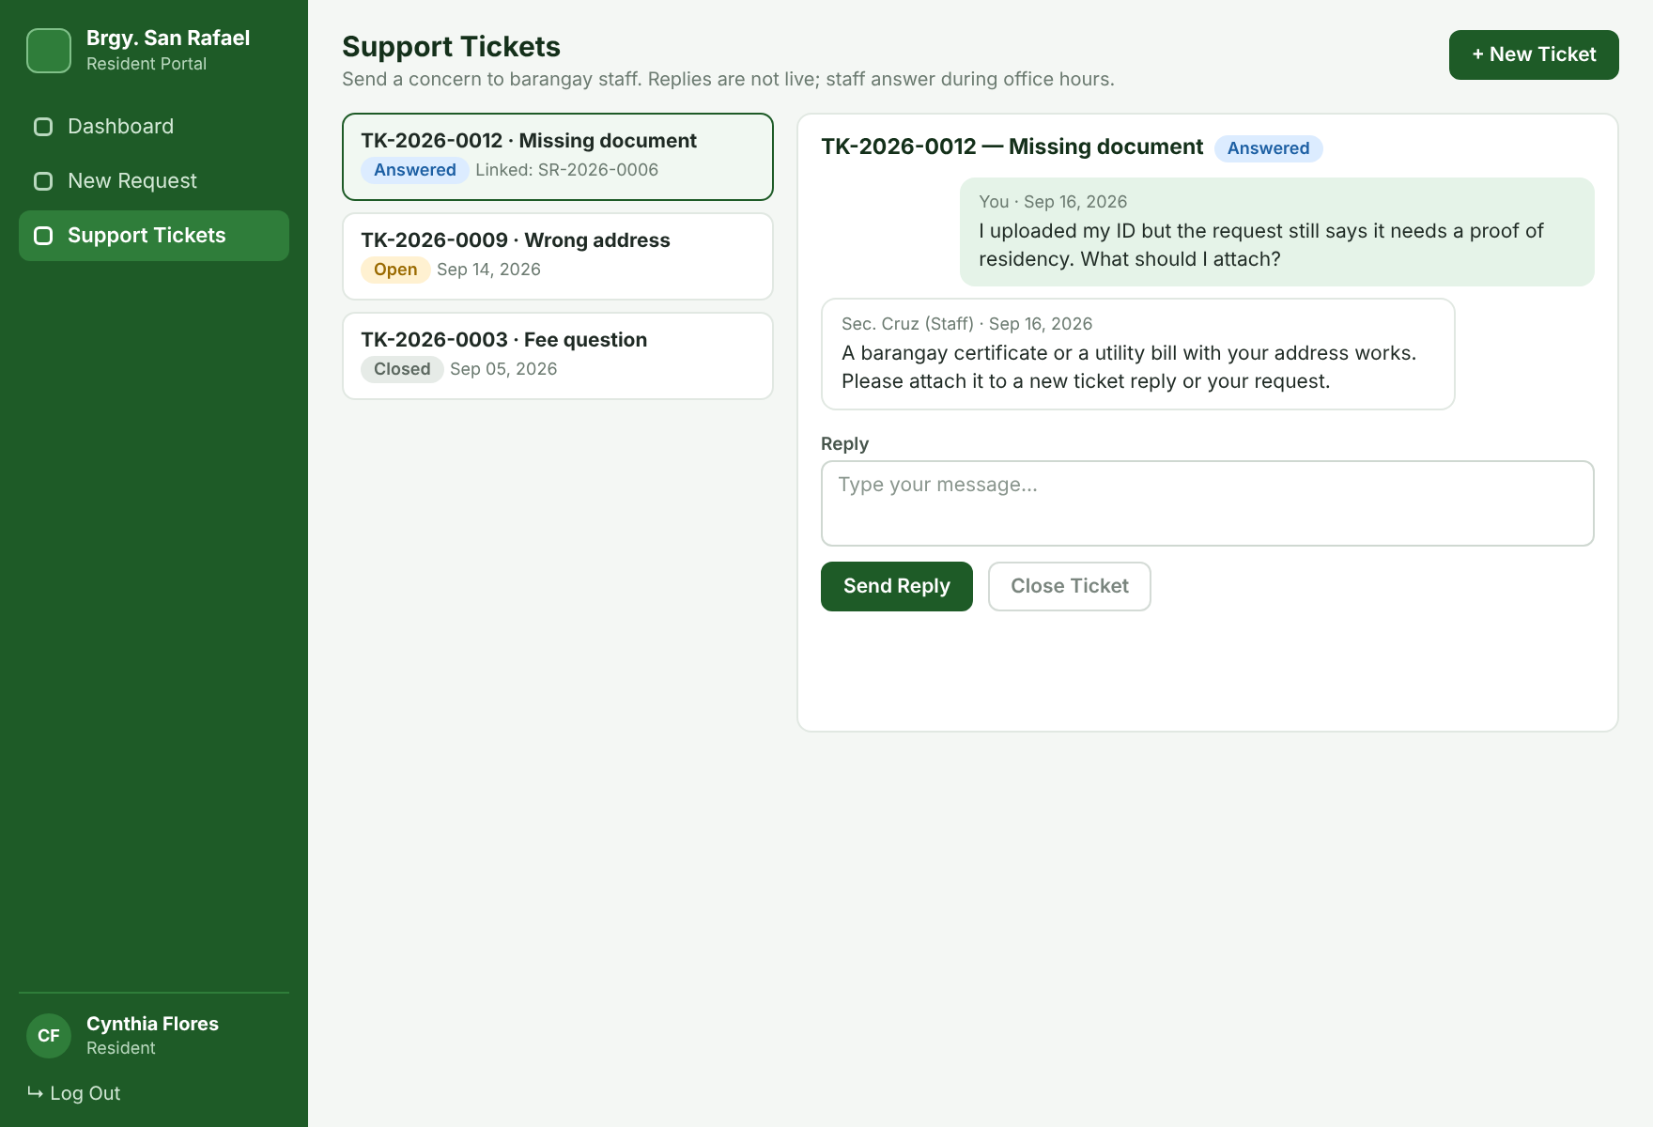
Figure 9. Resident Support Tickets Wireframe
Residents open tickets and read Staff replies. Tickets are asynchronous and carry the status Open, Answered, or Closed.
Screen 6 – Staff Dashboard
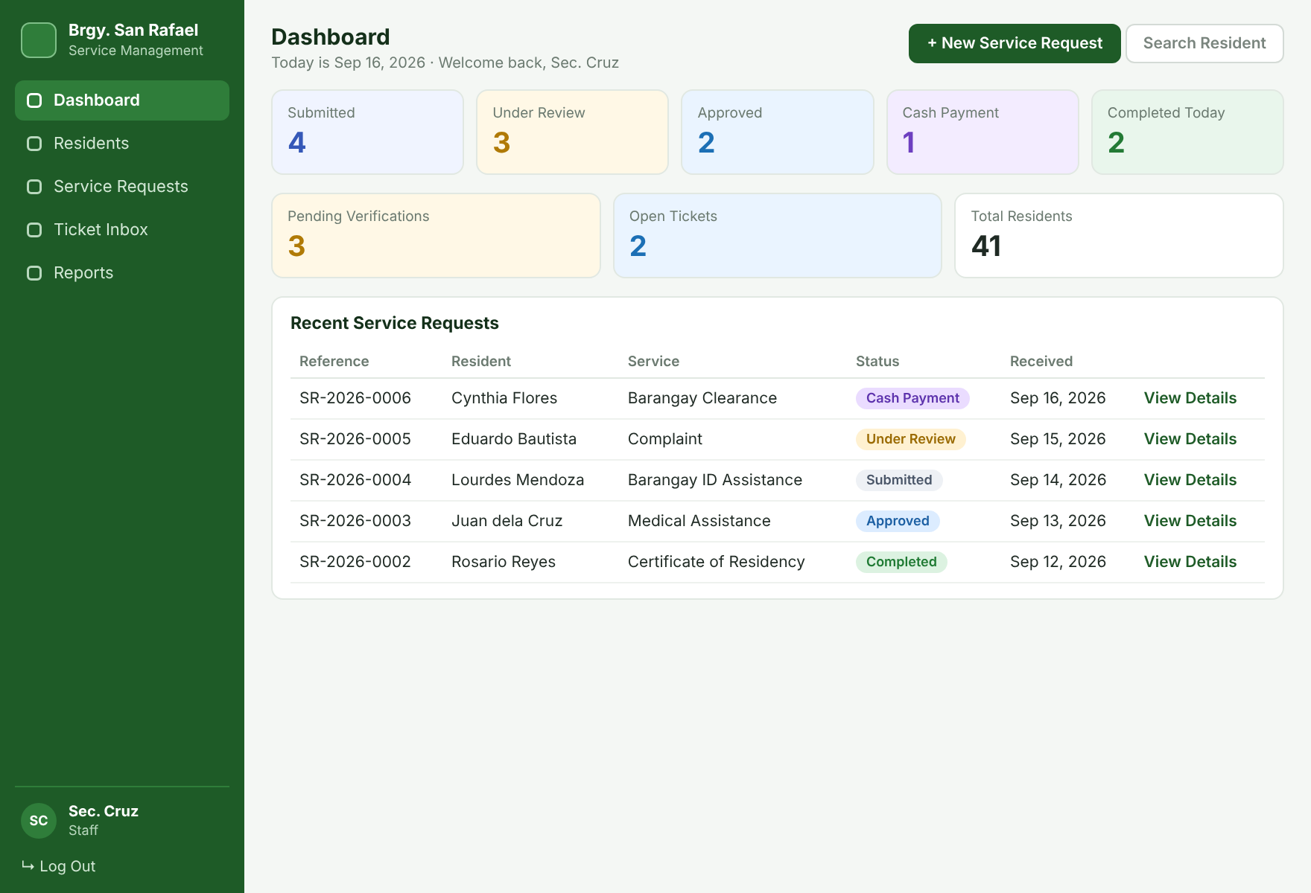
Figure 10. Staff Dashboard Wireframe
The dashboard focuses on requests by status, pending resident verifications, open tickets, recent transactions, and shortcuts to common tasks.
Screen 7 – Residents List
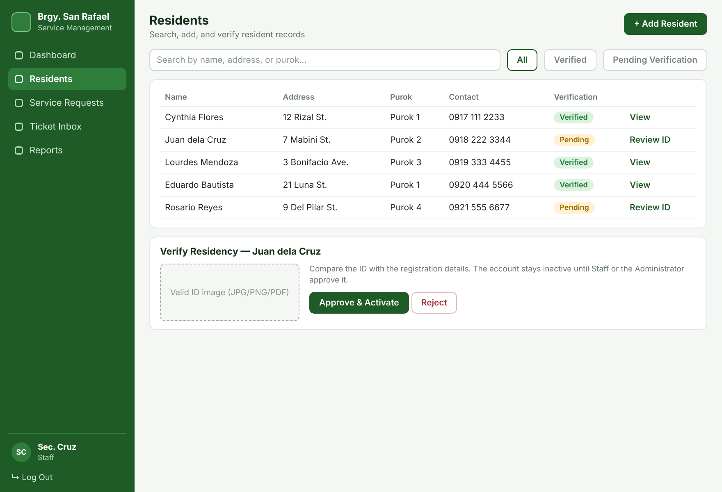
Figure 11. Residents List Wireframe
The records screen provides search and filtering so staff can find residents, add requests, and verify pending residents by reviewing the valid ID before activating the account.
Screen 8 – Add New Resident
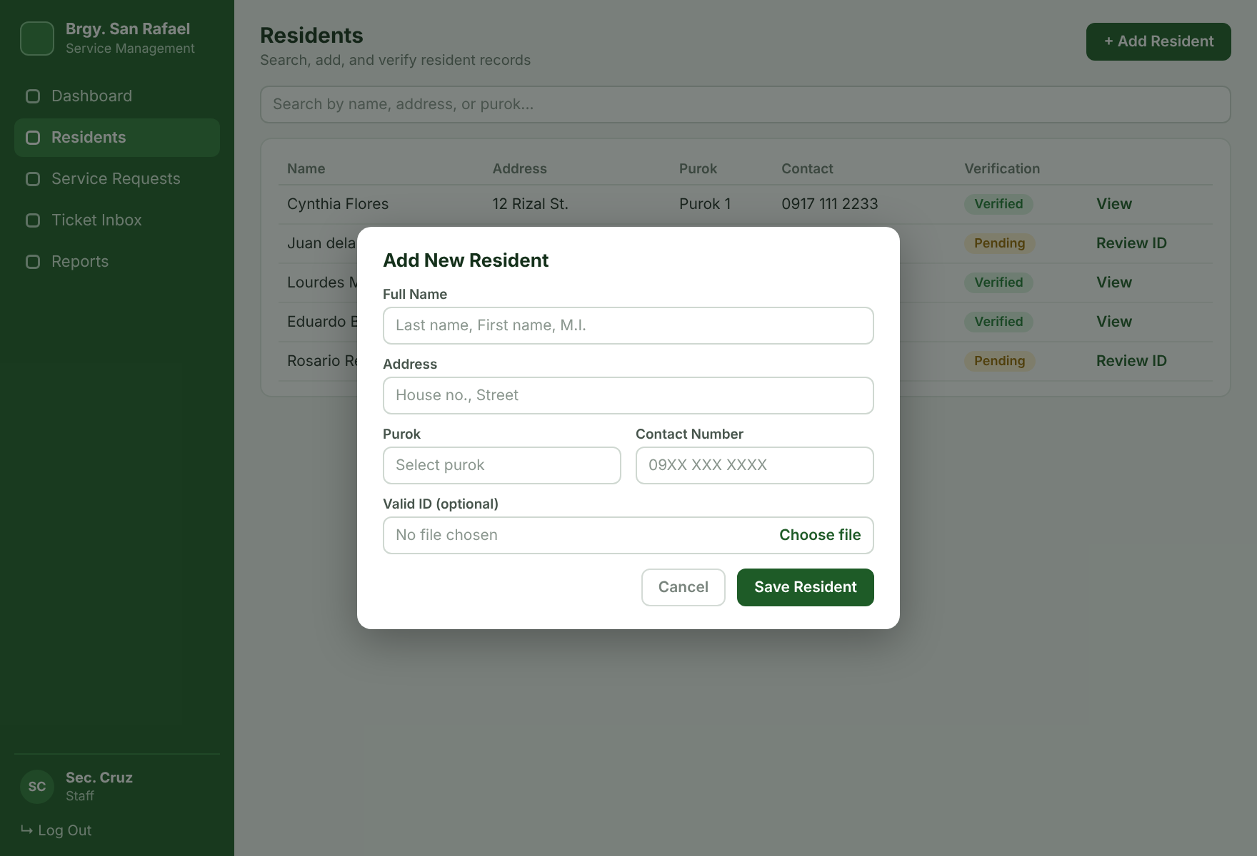
Figure 12. Add New Resident Wireframe
The Add New Resident modal provides the input of Name, Address, Purok, and Contact of a client, with an optional valid ID upload.
Screen 9 – Service Requests
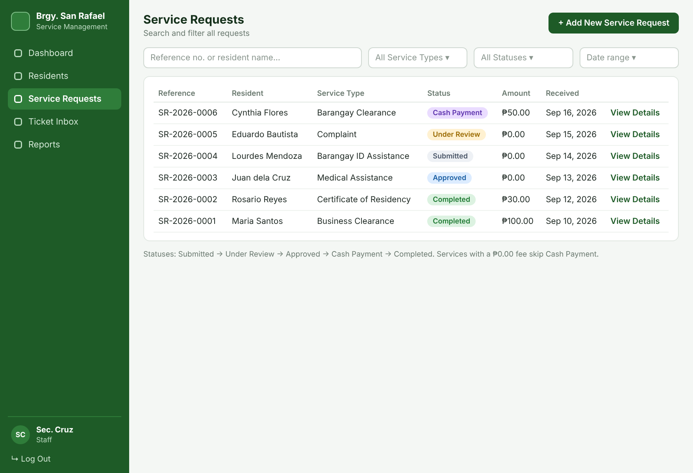
Figure 13. Service Requests Wireframe
This screen lists every request with its reference number, resident, service type, status, amount, and date received, with search by reference number or name and filters for service type, status, and date.
Screen 10 – Request Details
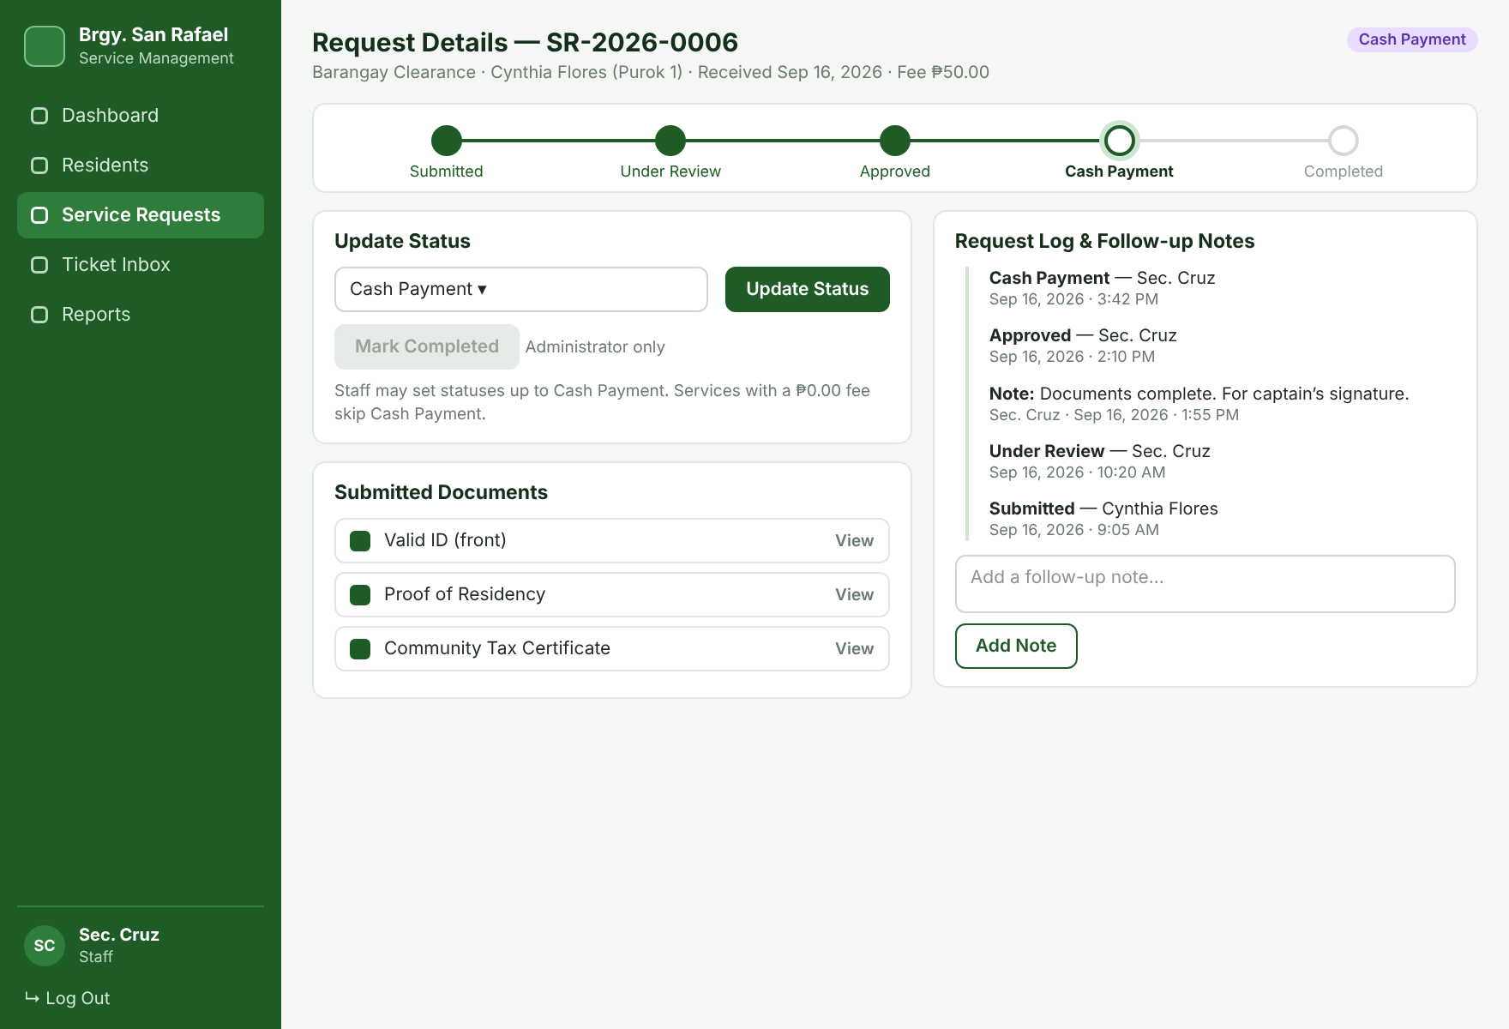
Figure 14. Request Details Wireframe
Request Details shows the submitted documents, the status tracker, and the request log. Staff update the status up to Cash Payment and add follow-up notes; Mark Completed is available to the Administrator only.
Screen 11 – Add New Service Request (Staff-Assisted)
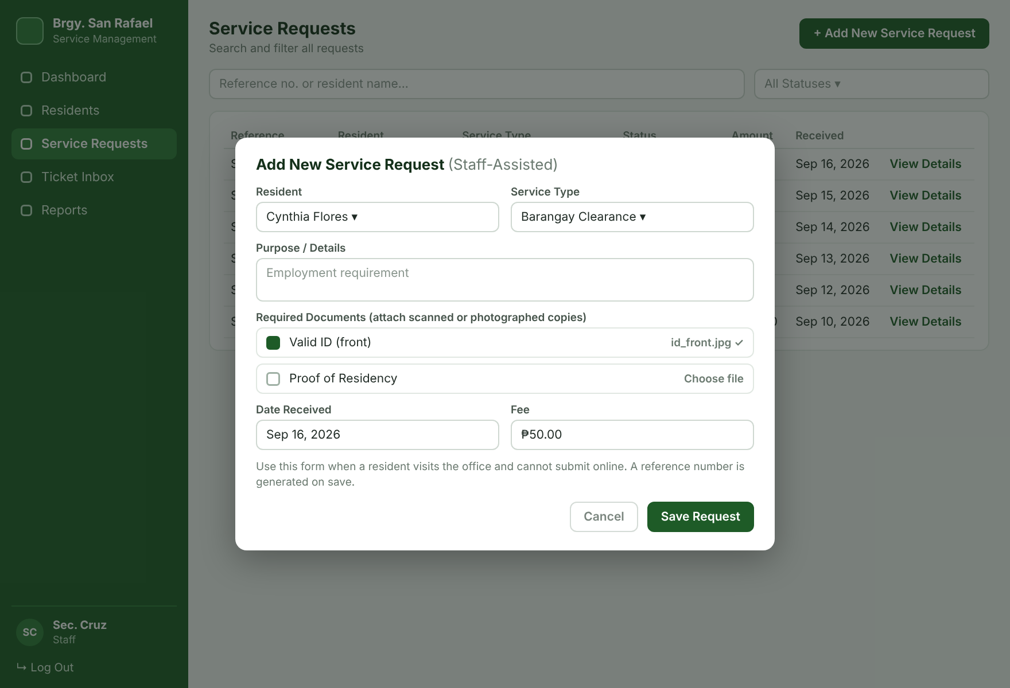
Figure 15. Add New Service Request (Staff-Assisted) Wireframe
The modal lets Staff create a request on behalf of a walk-in resident by choosing the resident and service type, attaching the required documents, and saving; a reference number is generated on save.
Screen 12 – Staff Ticket Inbox
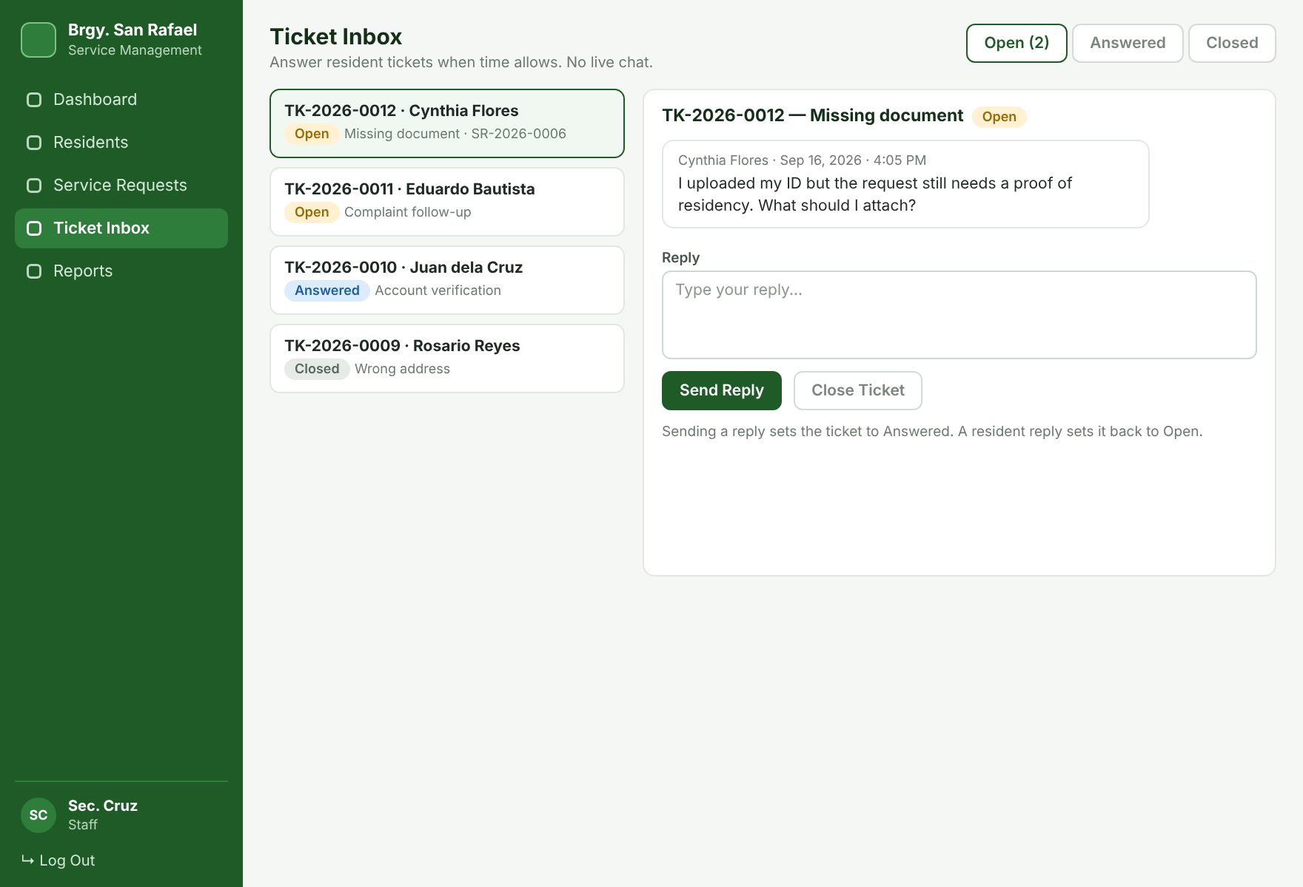
Figure 16. Staff Ticket Inbox Wireframe
The inbox lists resident tickets by status. Staff read a ticket, send a reply (status becomes Answered), and close the ticket when the concern is resolved.
Screen 13 – Service Types, Fees and Checklists (Administrator)
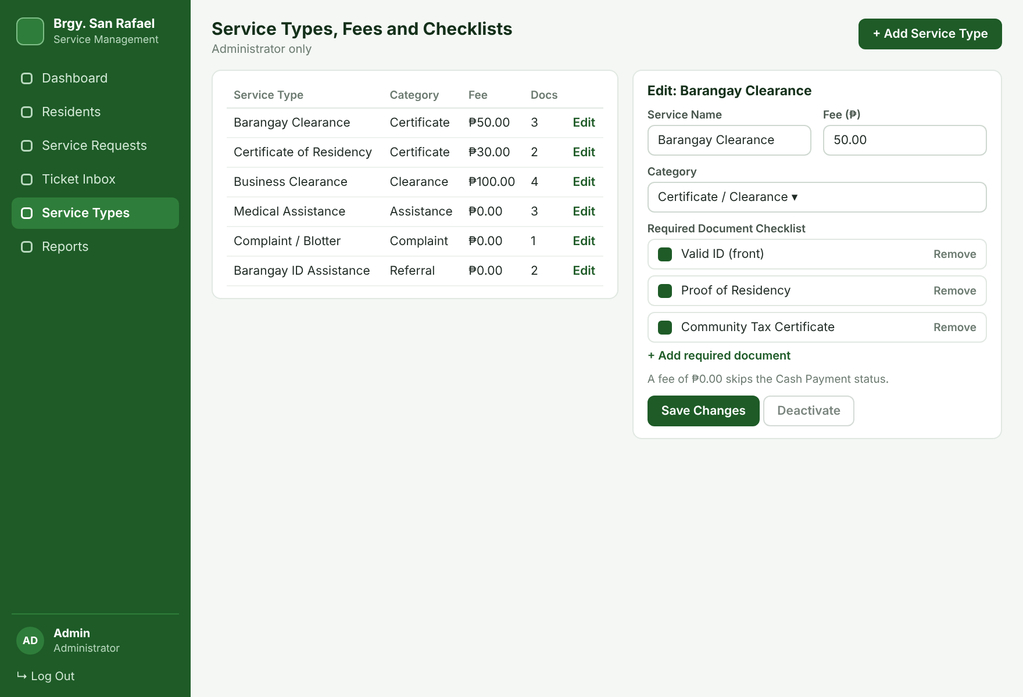
Figure 17. Service Types, Fees and Checklists Wireframe
The Administrator adds or edits service types, sets the fee (₱0.00 allowed), and maintains the required-document checklist that residents see on the submission form.
Screen 14 – Reports
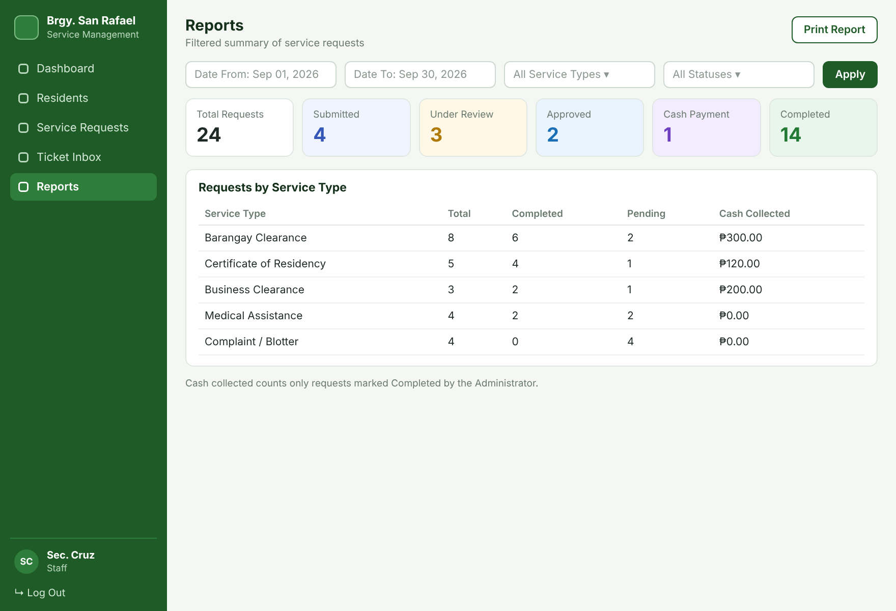
Figure 18. Reports Wireframe
The report board presents the filtered result of the total requests, the count for each status, and a breakdown by service type with cash collected. The board includes filtering for Date From, Date To, Service Type, and Status.
Screen 15 – Logout
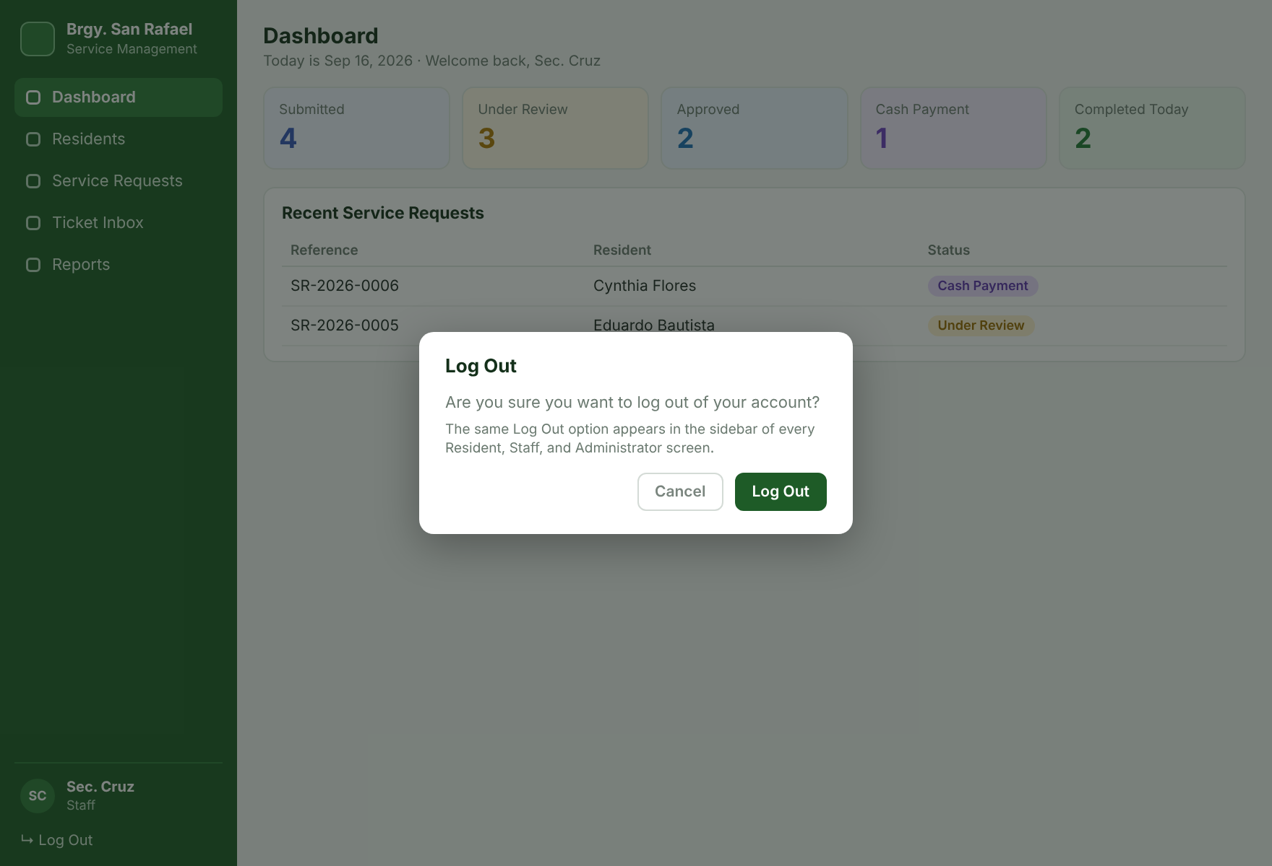
Figure 19. Logout Wireframe
The Log Out confirmation modal is available from the sidebar of every Resident, Staff, and Administrator screen.

14. Technology Selection
Category | Starter Technology | Reason / Team Decision
Front-end | Laravel Blade + HTML / CSS / Bootstrap / JavaScript | Simple server-rendered pages and responsive forms for three roles without a separate SPA framework.
Back-end | Laravel (PHP) | Matches the group's current coursework and beginner-level experience with routes, controllers, middleware, and models.
Database | MySQL | Appropriate for related users, residents, service types, requests, documents, logs, and tickets.
File Storage | Laravel private storage disk | Keeps uploaded valid IDs and request documents outside the public web folder and behind authentication.
IDE / Tools | Visual Studio Code + Composer + Git | Supports Laravel development, package management, and collaboration.
Development / Demonstration | Local Laravel environment; final demonstration deployment if required | Keeps development practical without unnecessary hosting complexity.

15. Usability Considerations
Usability Consideration | How It Will Be Applied
Clear button labels | Use New Request, Submit Request, Update Status, Add Note, Send Reply, Search, and Log Out.
Consistent navigation | Keep the sidebar with Dashboard, the role's main pages, and Log Out in predictable locations on every screen.
Simple forms | Use only needed fields, reuse saved resident information, and show the fee and required documents as soon as a service type is selected.
Plain-language status tracker | Show the five statuses as steps with the current step highlighted and a short instruction on what happens next.
Upload guidance | State the accepted file types (JPG, PNG, PDF) and the 5 MB limit beside each upload, and name the missing or invalid document in the error message.
Error messages | Identify invalid/missing fields and explain what should be corrected.
Confirmation messages | Confirm successful saves, important status changes, ticket replies, and show the reference number after submission.
Assisted use | Let Staff create requests on behalf of residents who cannot use the portal.
Privacy notice | Show the data-privacy consent notice at registration in plain language.
Readable text | Use clear hierarchy, readable table text, spacing, and uncluttered layouts.
Responsive interface | Use a responsive layout for different office monitor sizes and smaller resident screens.
Accessibility | Use descriptive labels and understandable status wording for non-technical users.

16. Requirements-to-Design Traceability

16.1 Traceability Matrix
The matrix links each functional requirement to the screens, database tables, and flowchart that realize it. Screen numbers refer to Section 13 and figure numbers to the flowcharts in Section 16.2.
FR | Requirement | Roles | Screens | Database Tables | Fig.
FR-01 | Login and role-based access | All roles | 1, 15 | users | 20
FR-02 | Service request creation | Resident, Staff | 4, 9, 11 | service_requests, service_types | 21
FR-03 | Resident record management | Staff, Administrator | 7, 8 | residents | 22
FR-04 | Status workflow and request log | Staff, Administrator | 9, 10 | service_requests, request_logs | 23
FR-05 | Follow-up notes | Staff, Administrator | 10 | request_logs | 24
FR-06 | Search and filter | Staff, Administrator | 7, 9 | residents, service_requests | 25
FR-07 | Staff dashboard | Staff, Administrator | 6 | service_requests, residents, tickets | 26
FR-08 | Reports | Staff, Administrator | 14 | service_requests, request_logs | 27
FR-09 | Registration and verification | Resident, Staff, Administrator | 2, 7 | users, residents | 28
FR-10 | Dynamic checklist and uploads | Resident, Staff | 4, 10, 11 | document_requirements, request_documents | 21
FR-11 | Resident dashboard and status tracking | Resident | 3 | service_requests, request_logs | 29
FR-12 | Cash-upon-delivery fulfillment | Resident, Staff, Administrator | 3, 10 | service_requests, request_logs | 30
FR-13 | Issue ticketing | Resident, Staff, Administrator | 5, 12 | tickets, ticket_messages | 31
FR-14 | Service types, fees, and checklists | Administrator | 13 | service_types, document_requirements | 32

16.2 Design Flowcharts

FR-01 – Authentication and Role-Based Access
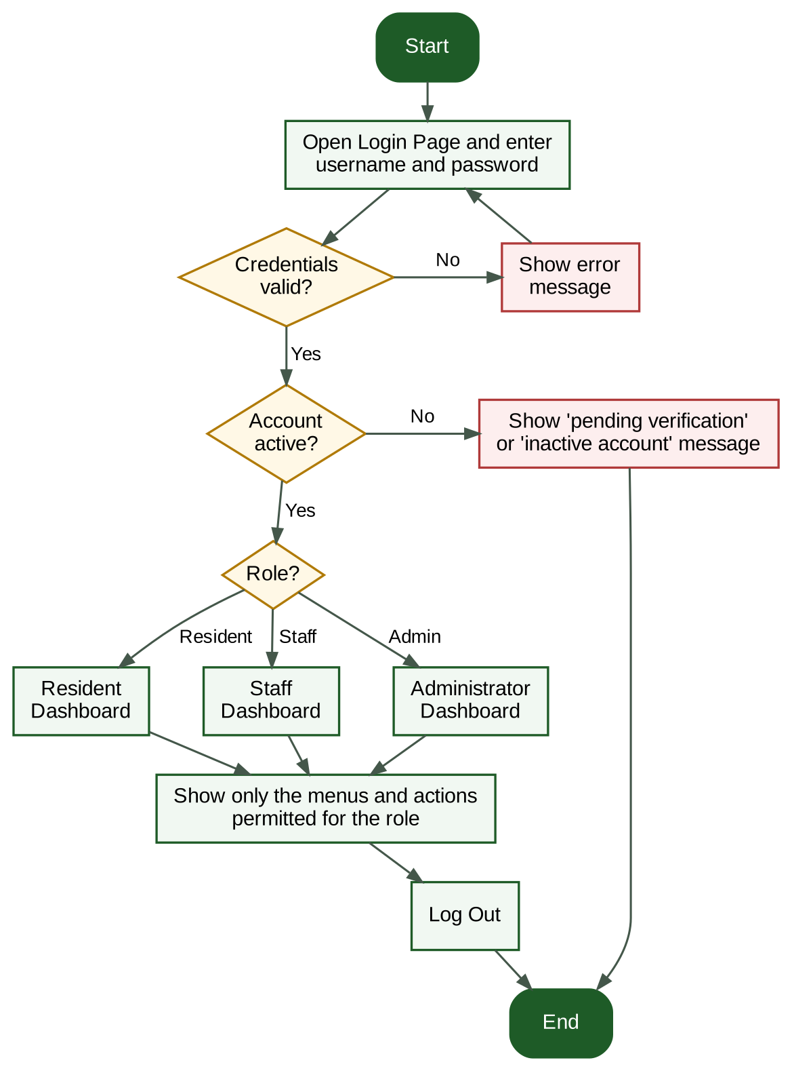
Figure 20. Login Flowchart
Only authenticated, active users can access the system, and each role sees only its permitted menus.

FR-02 and FR-10 – Service Request Creation, Dynamic Checklist and Uploads
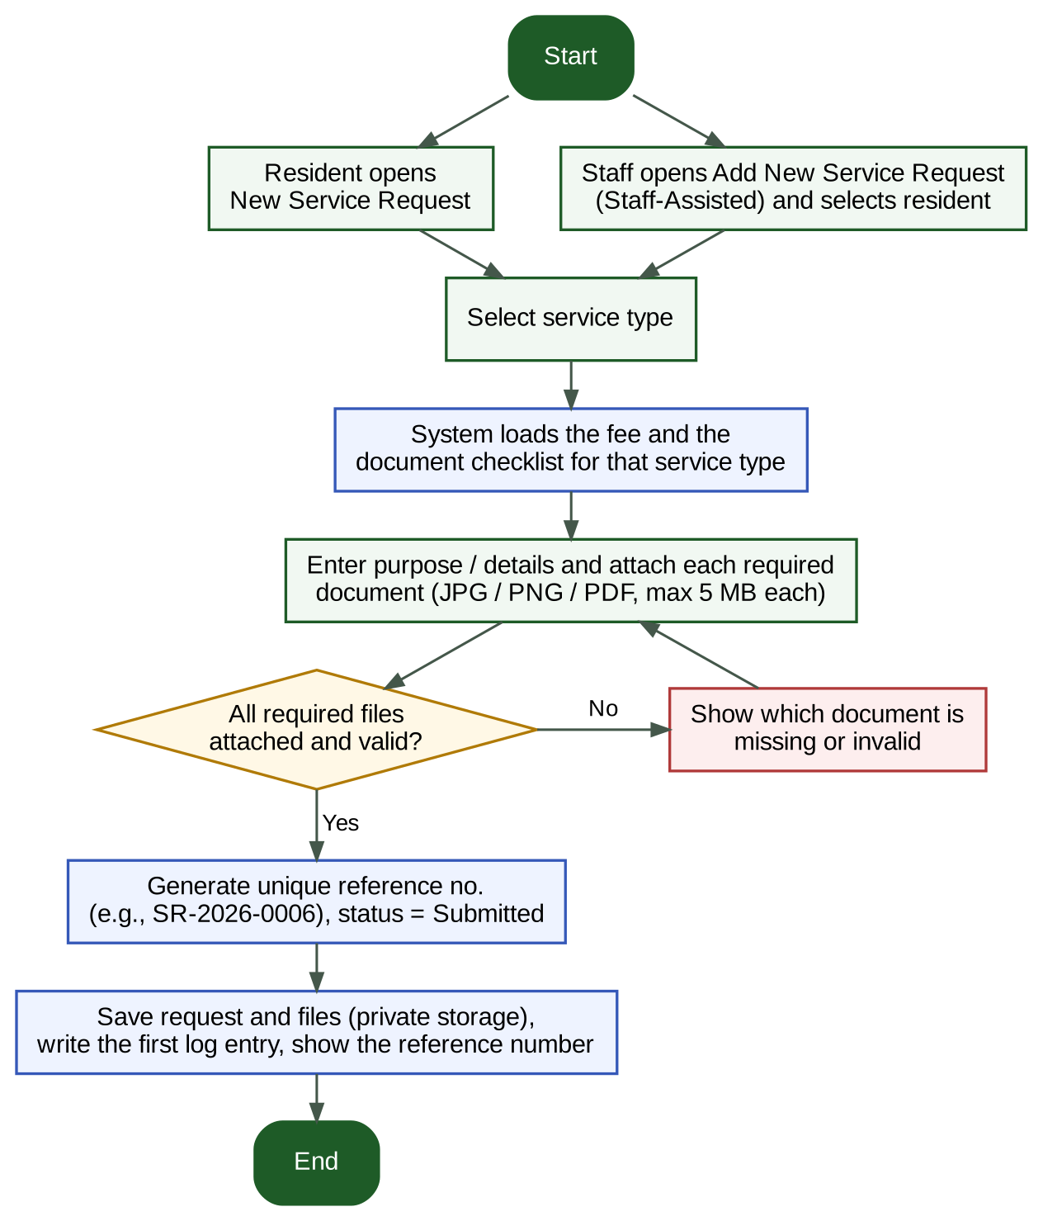
Figure 21. Service Request Submission Flowchart
A Service Request is recorded under the selected service type with a unique reference, after the required documents for that service are attached.

FR-03 – Resident Management
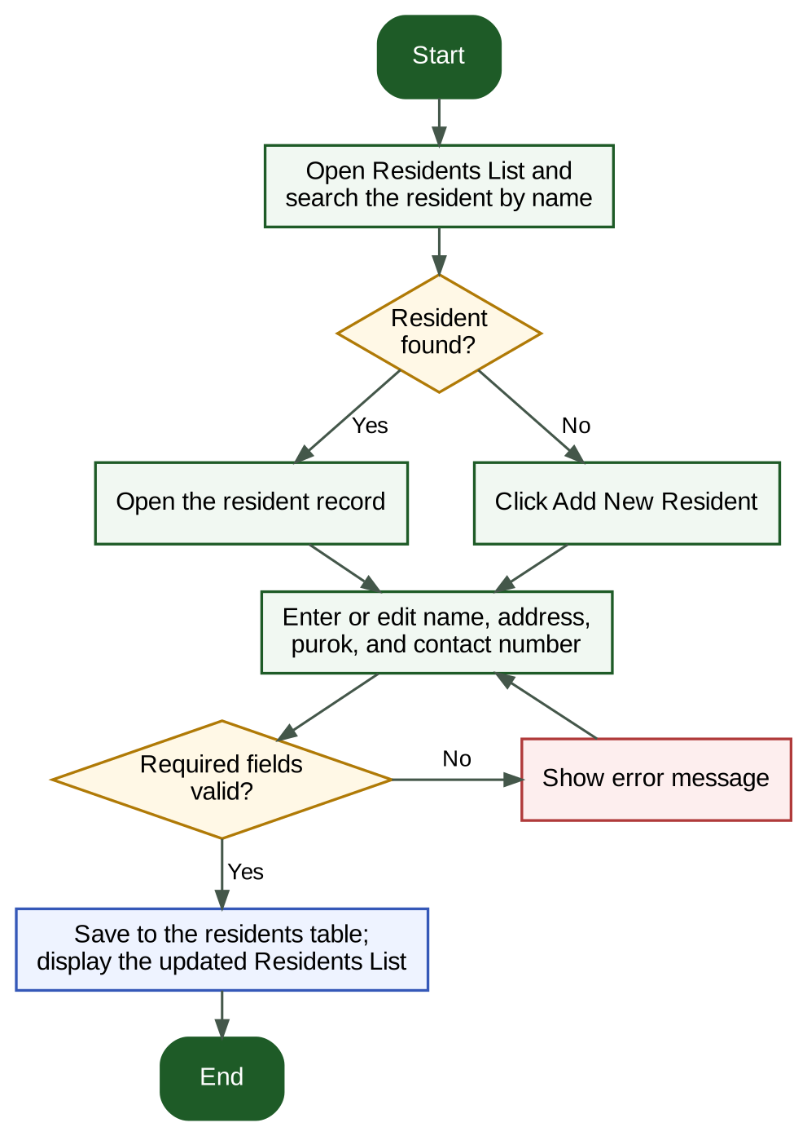
Figure 22. Resident Management Flowchart
A reusable resident record can be maintained for future Service Requests.

FR-04 – Status Workflow and Request Log
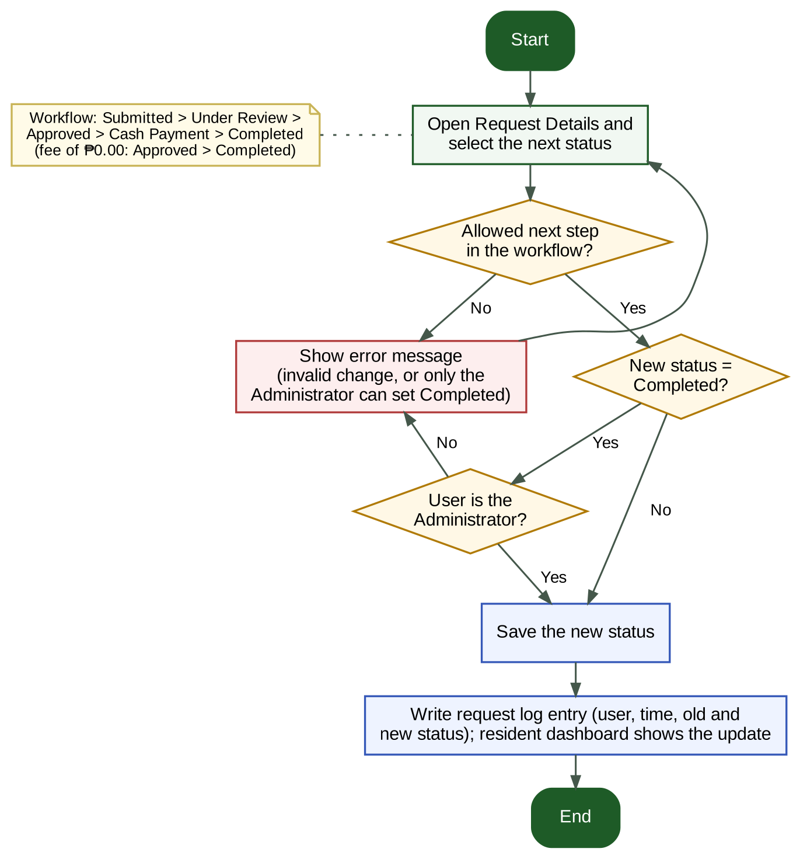
Figure 23. Status Workflow Flowchart
The current Service Request status is recorded and can be updated by authorized users; only the Administrator can set Completed.

FR-05 – Follow-up Management
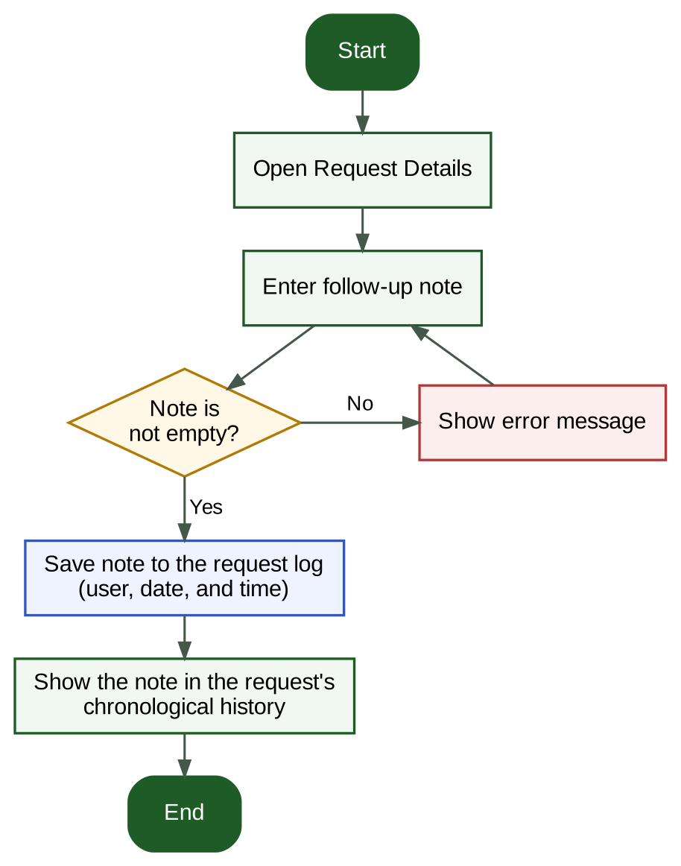
Figure 24. Follow-up Notes Flowchart
Follow-up actions remain attached to the Service Request history.

FR-06 – Search / Filtering
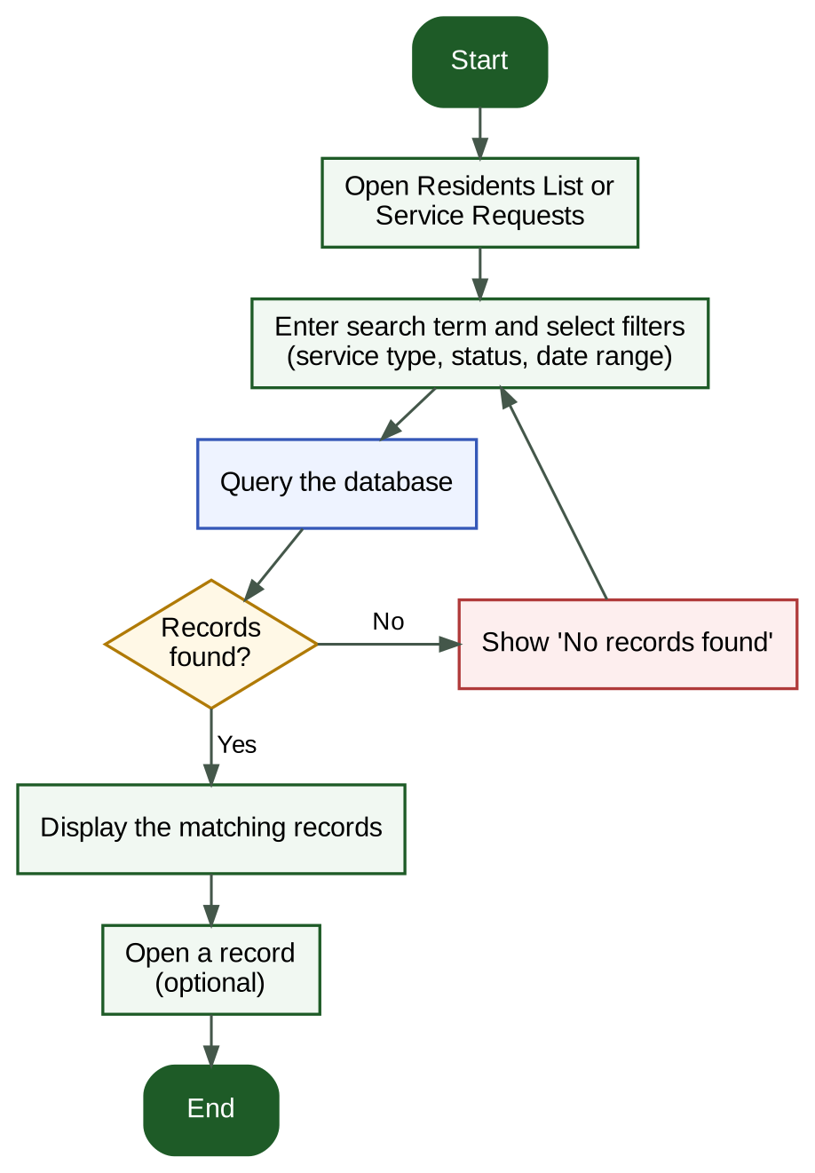
Figure 25. Search and Filter Flowchart
Staff can locate resident and Service Request records using search and filtering.

FR-07 – Dashboard Monitoring
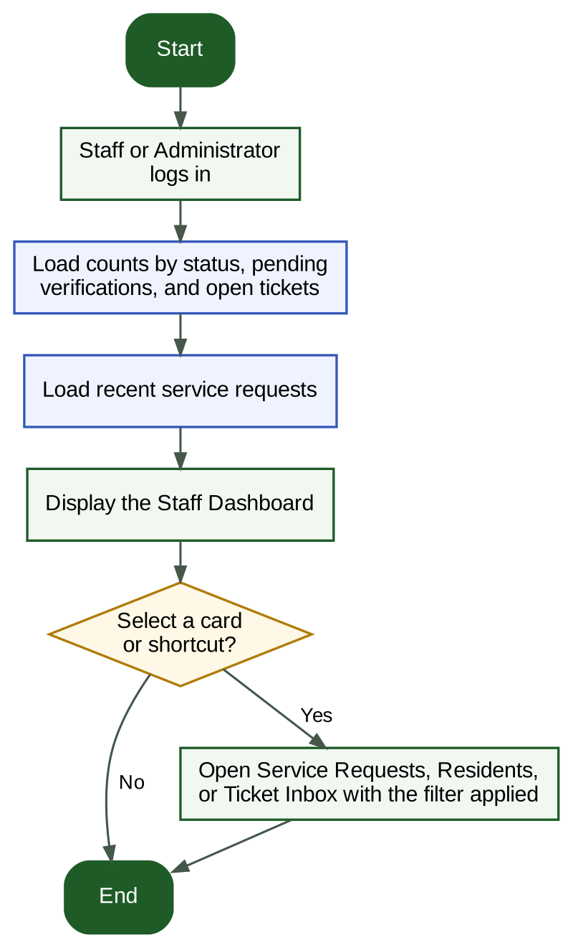
Figure 26. Staff Dashboard Flowchart
Requests by status, pending verifications, and open tickets are visible for staff monitoring.

FR-08 – Reports
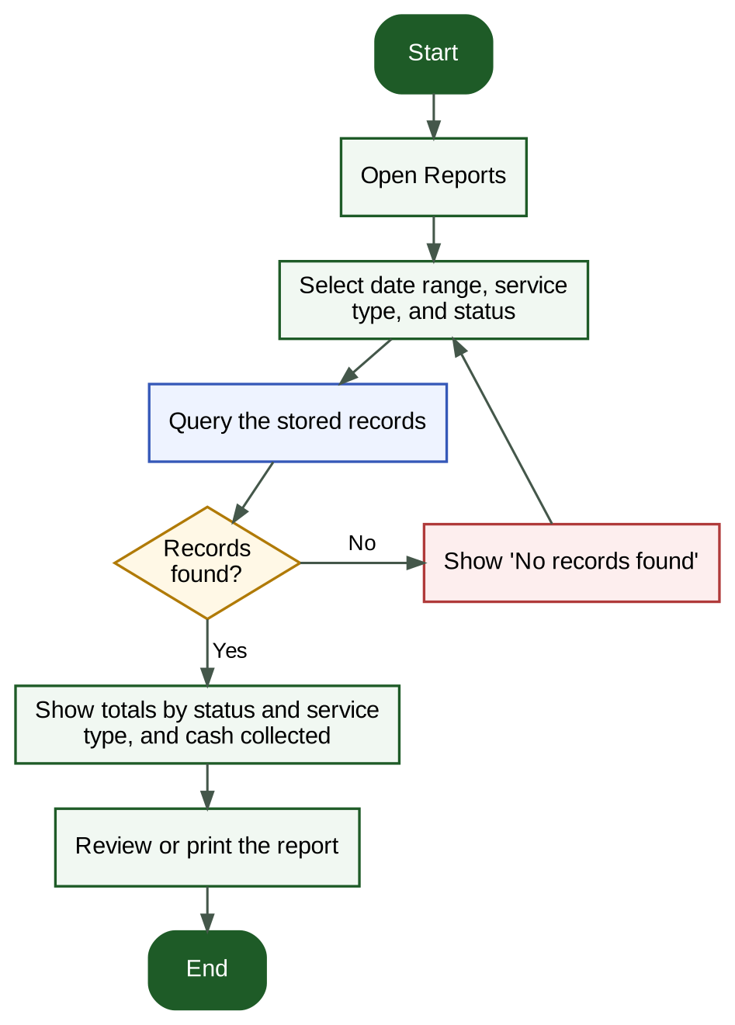
Figure 27. Reports Flowchart
Stored records support basic reports.

FR-09 – User Registration and Verification
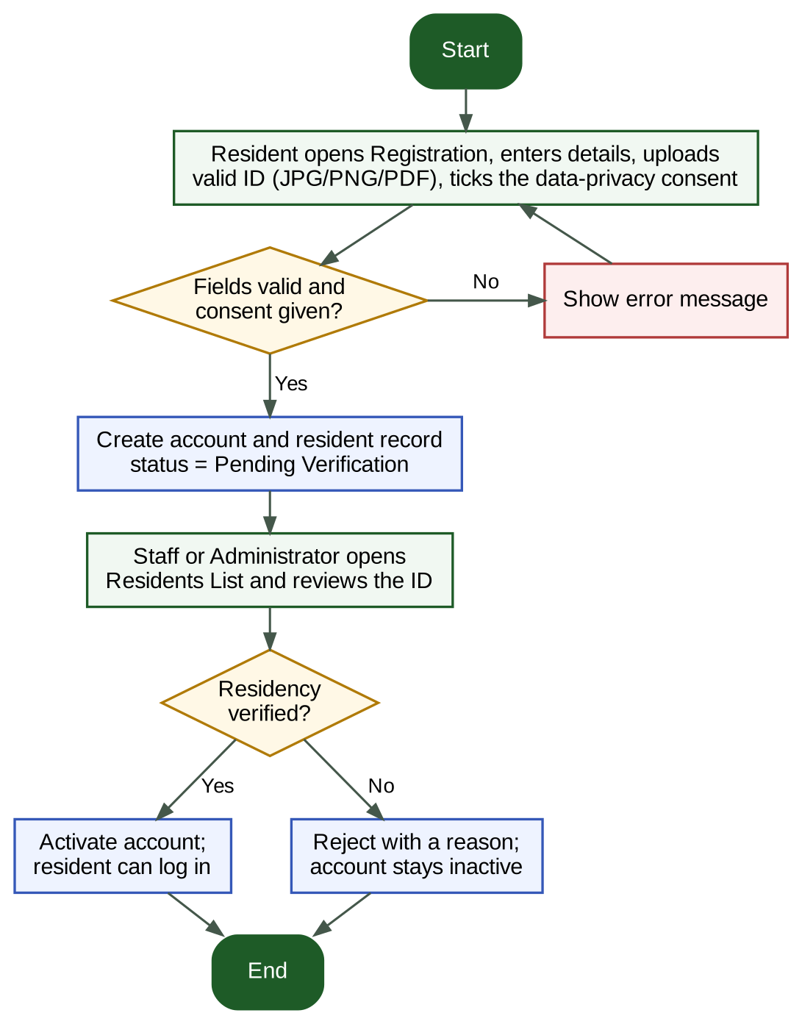
Figure 28. Registration and Verification Flowchart
A resident account stays inactive until Staff or the Administrator verify the valid ID.

FR-11 – Resident Dashboard and Status Tracking
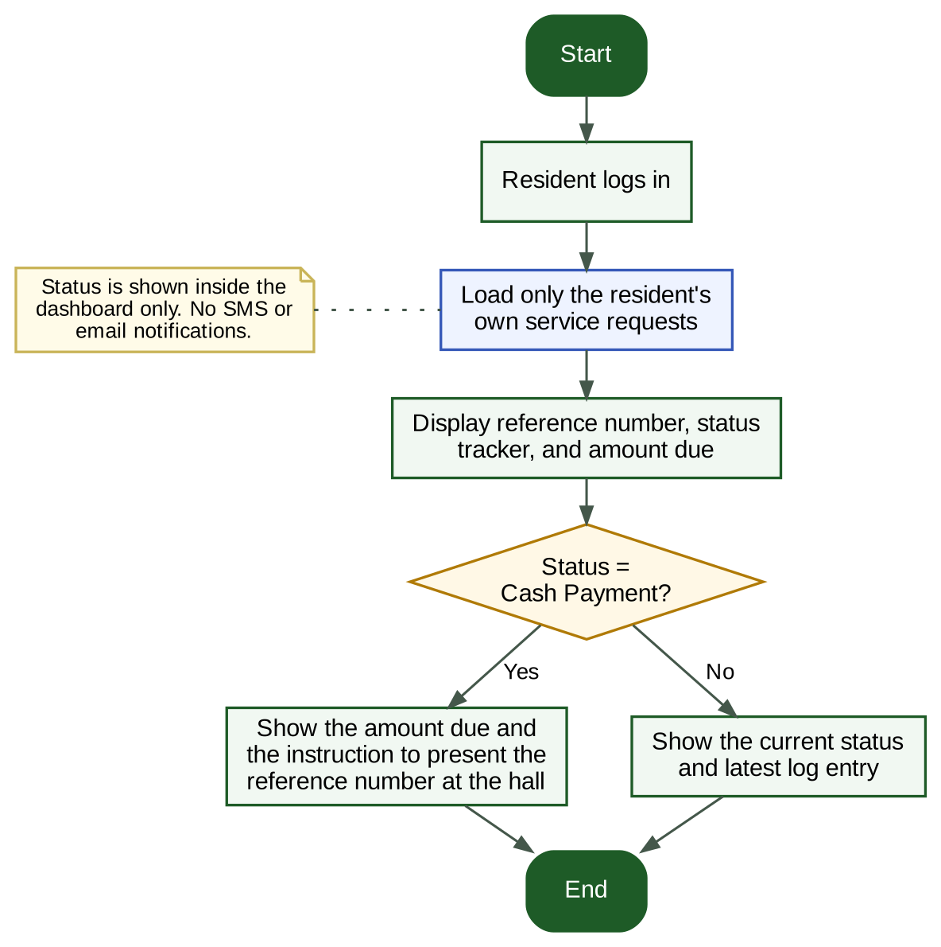
Figure 29. Resident Dashboard Flowchart
A resident sees only his or her own requests, status tracker, and amount due.

FR-12 – Cash-Upon-Delivery Fulfillment
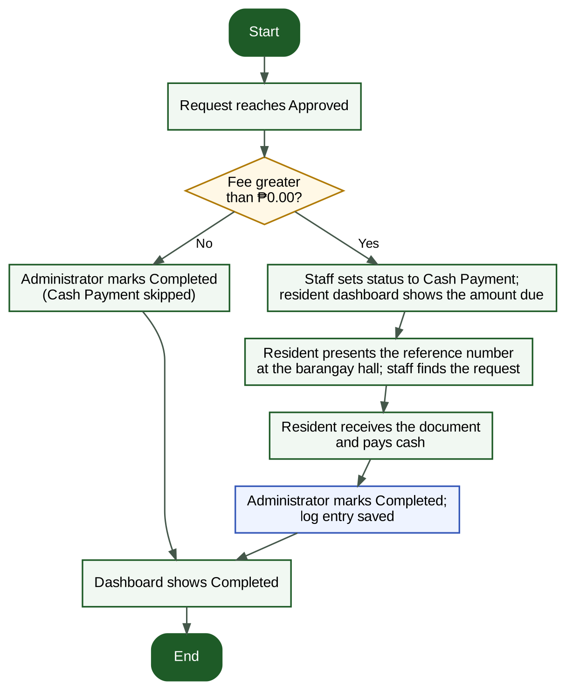
Figure 30. Cash-Upon-Delivery Flowchart
The resident pays cash at the barangay hall upon receiving the document, and the Administrator marks the request Completed.

FR-13 – Issue Ticketing
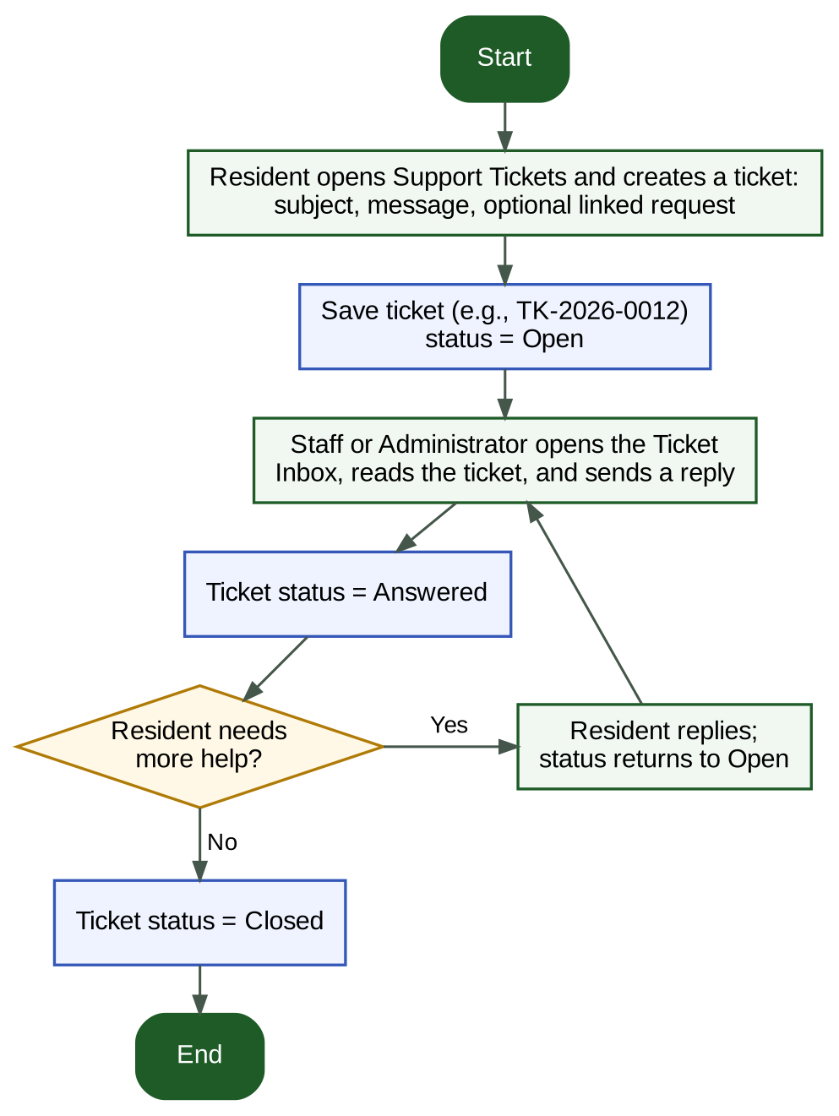
Figure 31. Issue Ticketing Flowchart
Tickets move from Open to Answered to Closed through asynchronous replies.

FR-14 – Service Types, Fees, and Checklists
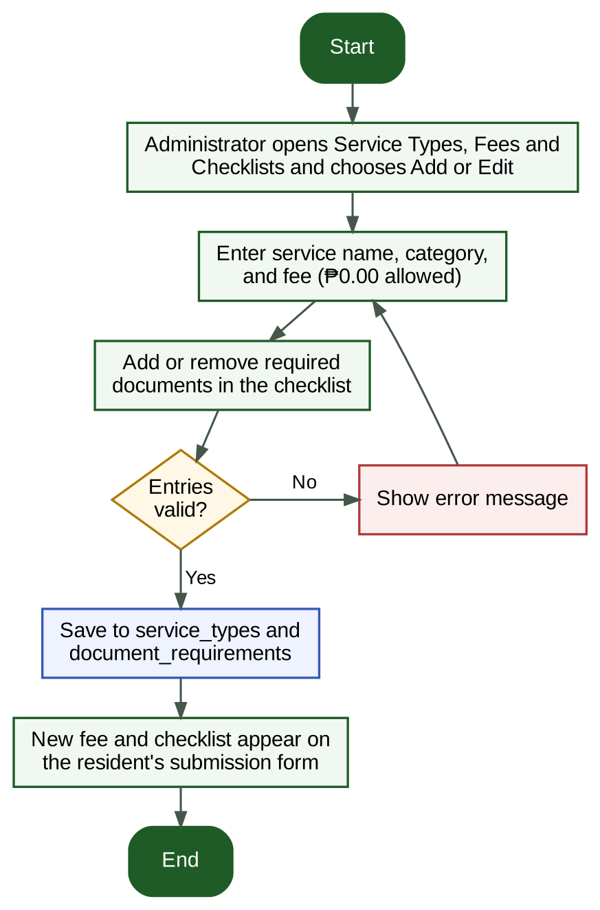
Figure 32. Service Type Management Flowchart
The Administrator controls the services, fees, and document checklists that residents see.

17. Consultation and Revision – Meeting Agenda
On 15 September 2026, project instructor Sir Michael Baltazar provided the initial scenario, document details, and project requirements, and subsequently reviewed the working draft. He requested that the client context be added, the central problem and objectives be aligned, the scope be narrowed, and the functional and non-functional requirements be supported by diagrams and descriptions, along with the corresponding architecture, data flow, navigation, and interface visuals.
After reviewing the working draft, the group revised the design so that residents have their own accounts instead of being passive records. The table below lists the revisions and the sections they affect. These revisions come from internal project-team consultation and do not claim that an external Barangay interview occurred.
Revision Item | Summary of the Change | Sections Affected
Resident accounts and verification | Added the User/Resident role. Residents register with a valid ID; Staff or the Administrator verify residency before activation. | 1.3, 3, 4, 7 (FR-09), 10, 13, 16
One status workflow | Replaced Pending, In Progress, and Completed with Submitted, Under Review, Approved, Cash Payment, and Completed. Only the Administrator sets Completed; ₱0.00 services skip Cash Payment. | 5, 7 (FR-04), 13, 16
Dynamic document checklist | The required documents change with the selected service type; uploads are JPG, PNG, or PDF up to 5 MB each; the Administrator maintains service types, fees, and checklists. | 7 (FR-10, FR-14), 9, 10, 13
Cash-upon-delivery fulfillment | Fulfillment is offline: the resident presents the reference number at the barangay hall and pays cash upon receipt. No online payments. | 6, 7 (FR-12), 11
Asynchronous issue ticketing | Replaced live chat with tickets (Open, Answered, Closed), because live chat would overwhelm an understaffed office. | 6.3, 7 (FR-13), 13
Status inside the dashboard only | No SMS or email notifications; residents see status in their dashboard. | 6.3, 7 (FR-11)

18. Final Proposed Design
The project uses the supplied Barangay San Rafael scenario as its client context. The record above documents internal project-leader feedback and does not claim that an external Barangay interview occurred.

18.1 Final Design Overview
The proposed design centers on a centralized service-request record with three roles, a verified resident portal, a dynamic document checklist, one status workflow, cash-upon-delivery fulfillment, asynchronous issue tickets, searchable records, and basic reporting. It is intended to help residents and authorized barangay personnel organize request information and follow-up actions while remaining realistic within the scenario's limited resources and continued paper requirements.

18.2 Expected Benefits
- More organized retrieval of service-request information.
- Clearer visibility of pending and completed work.
- More consistent recording of request and follow-up details.
- Less dependence on searching across multiple separate records for routine lookups.
- Fewer repeat visits, because residents see their status and required documents in their own dashboard.
- Fewer incomplete submissions, because the checklist shows the required documents for the selected service.
- Better support for preparing basic reports and monitoring.

18.3 Final Design Assumptions
The implementation assumes access to at least one suitable computer for the Laravel application and MySQL database. Staff will receive basic orientation on login, resident verification, service requests, status updates, follow-ups, tickets, and reports, and residents will receive plain instructions on registering and submitting a request. The MVP does not depend on an external notification service or an online payment gateway. The final design connects the manual-record problem to a manageable Laravel/MySQL system for centralized requests, tracking, and reporting.
The final system is a web-based Community Service Request Management System for Barangay San Rafael. It will be implemented using Laravel, Blade, HTML/CSS/Bootstrap, and MySQL. The MVP uses three application roles: Administrator, Staff, and User/Resident. Residents register their own accounts, which are activated after residency verification.
The core transaction is the Service Request. It stores the requester, service type, purpose, reference number, status, fee, uploaded documents, and request log. Certificate/clearance, complaint, and assistance/referral concerns are represented as service types within the same workflow, avoiding separate complex subsystems. Residents also have an issue ticketing system that replaces live chat.
Official signatures and paper documentation remain outside the digital workflow where required. The system records processing status and follow-up information for monitoring while excluding digital signatures, online payments, live chat, SMS/email notifications, advanced analytics, and unrelated systems from the MVP.
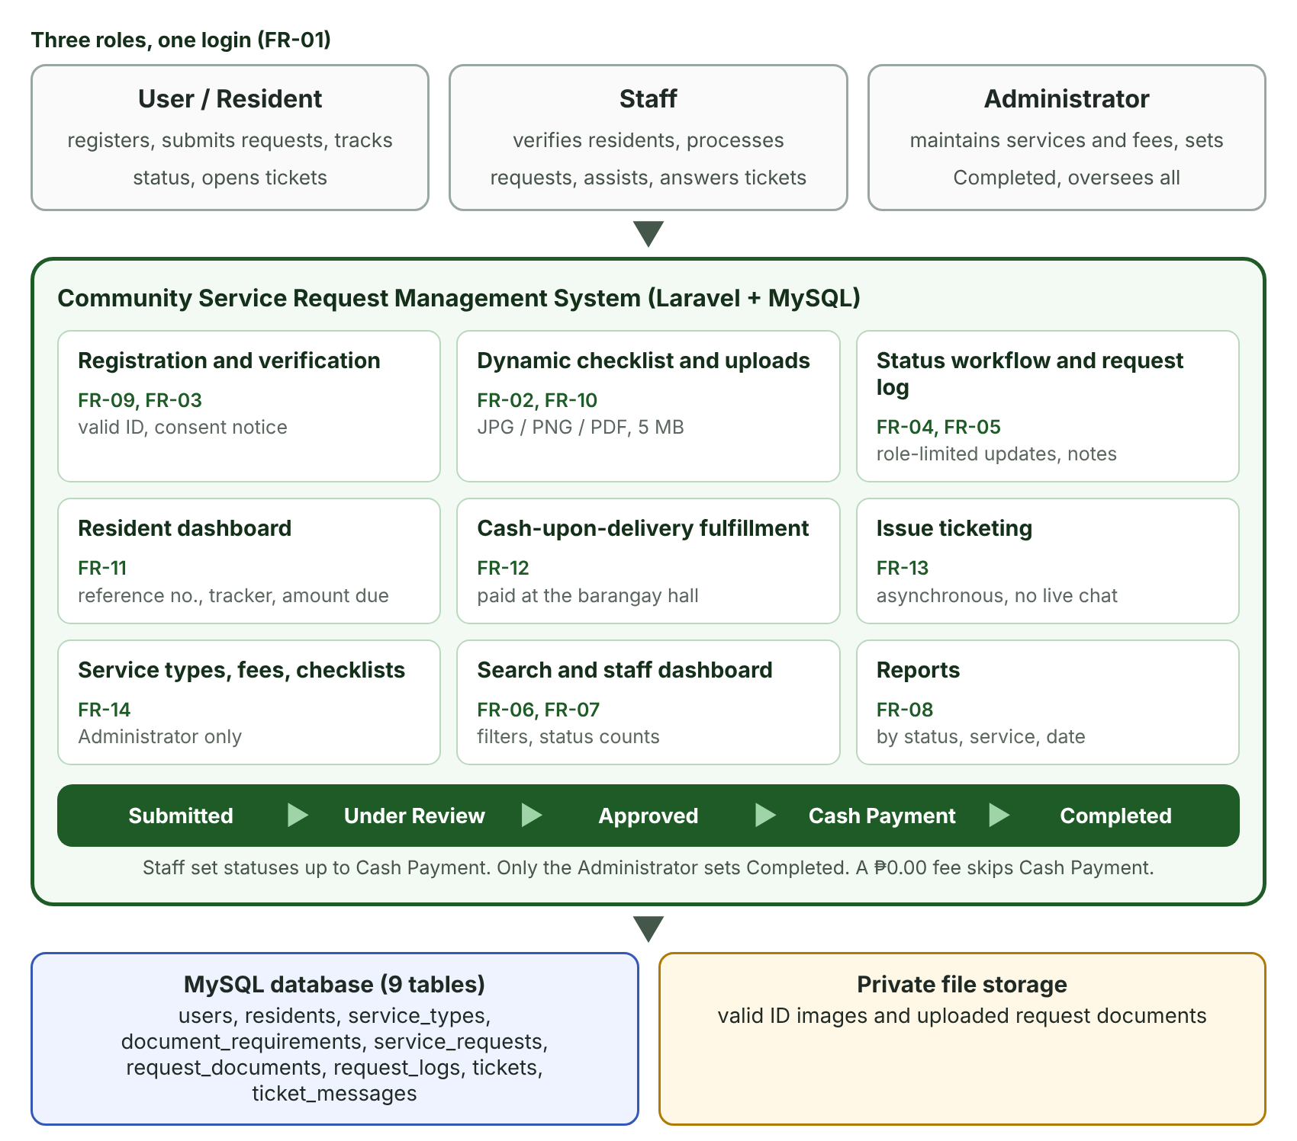
Figure 33. Final System Overview
Three roles share one Laravel and MySQL system built around the Service Request and its status workflow.

19. Conclusion
The Community Service Request Management System for Barangay San Rafael is designed to address fragmented logbooks and spreadsheets, inconsistent resident information, difficulty locating requests, separated follow-up notes, manual reporting, and residents' repeated visits to ask about their requests. The Laravel and MySQL implementation centralizes resident and request records while providing verified resident accounts, a dynamic document checklist, one status workflow, cash-upon-delivery fulfillment, asynchronous issue tickets, search, dashboard monitoring, and basic reports. Its focused scope is intentional so the group can realistically implement and demonstrate the core system while considering privacy, usability, limited resources, and procedures that still require paper documentation.

